SS9: Famous Inventors Research Assignment

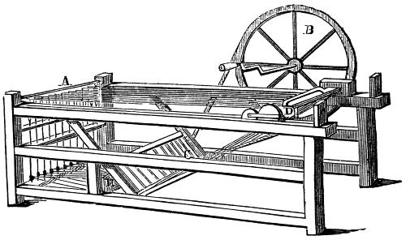

Over the past month we have examined the English Revolution and the French Revolution. We will now be turning our attention to a different type of revolution: the Industrial Revolution. To begin this unit, everyone will be choosing an inventor to research and filling out an essay plan. Along with your essay plan, you will be required to hand in Cornell Style notes and a formal bibliography.

Your Assignment:
- In 500 words max., you must answer the following question:
Explain why the person you have selected could/should be considered one of the most important inventors in history. (12 marks)
- To organize your research you must use Cornell Style notes ( 3 pages, using key words) (27 marks)
- You must also include a Reference List (APA format) using a minimum of 3 sources (minimum of 2 print sources). Use the sheets provided by the teacher librarian in the LRC. (6 marks)

- Joseph Marie Jacquard (loom)
- Alexander Graham Bell (telephone)
- Gotlieb Daimler (engine)
- Rudolf diesel (engine)
- Henry Ford (assembly line)
- James Watt (condensing steam engine)
- Henry Cort (iron purity)
- Michael Faraday (optic glass/electricity)
- George Stephenson (safety lamp/mining)
- Samuel Morse (Morse code)
- William F. Talbot (photogenic drawing)
- Thomas Newcomen (steam engine)
- Charles Goodyear (rubber)
- Nikola Tesla
- Wilbor/Orville Wright
- Andrew Carnegie
- Cyprus Mc Cormick
- Samuel Crompton (spinning mule)
- Henry Cavendish (many scientific exp.)
- Robert Owen
- Guglielno Marconi (wireless)
- Louis Daguerre (daguerreotype)
- John Kay (fly shuttle weaving)
- Thomas Edison (over 1000)
- Jethro Tull (seed drill)
- Henry Bessemer (steel)
- Thomas Savery (polishing glass)
- Robert Fulton (3 patents)
- Eli Whitney (cotton gin)
- Ed Cartwright (power loom)
- Richard Arkwright (spinning frame)
- James Hargreaves (spinning jenny)
- William Perkin (aniline dyes)
- Elizabeth Fry (prison reform)
- William Murdock
- Isaac Singer
- George Eastman
- Dr. Richard Gatling

