Influencing Government (p258-267)

- Vote!

Use your democratic right to vote for the MP or MLA that you think is best

- Contact your local MP or MLA by phone, email, or just walk in to their office

Lana Popham MLA Saanich

Elizabeth May MP Saanich/Gulf Islands

3) Join a Pressure Group (Institutionalized or Issue-oriented)

- Institutionalized are well established and have formal organizations

- Issue orientated pressure groups are less permanent

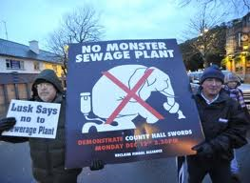

- Pressure groups provide polls, reports, petitions, and advice to gov’t
- Lobbyists are paid to represent the interests of a particular group (not always good for society)

- Use Mass Media – Television, Radio, Newspapers, Internet, Billboards (advertising).
- If most media is owned by few companies, critics say the media may be biased. Goes against the intent of democracy.

5) Civil Disobedience – The act of intentionally breaking laws one considers unjust

- If voting, contacting MPs or MLAs, joining pressure groups, and informing the media doesn’t work, Civil Disobedience is the last resort to influence government

