**Chapter 1 Review** **Section 1.1**

**FUNCTION OPERATIONS**

**1.** Determine *h*(*x*)  *f* (*x*)  *g*(*x*).

**a)** *f* (*x*)   *g*(*x*)  12

**b)** *f* (*x*)  2*x*  7 *g*(*x*)  5*x*  11

**c)** *f* (*x*)  *x*2  3*x*  2 *g*(*x*)  *x*2  *x*  5

**d)** *f* (*x*)  (*x*  4)2 *g*(*x*)  7*x*  1

**2.** Consider the functions *f* (*x*)  3*x*  5 and  
*g*(*x*)  *x*2  1.

**a)** Determine the equation of *h*(*x*)  ( *f*  *g*)(*x*).

**b)** Sketch the graphs of *f* (*x*), *g*(*x*), and *h*(*x*) on the same set of axes.

**c)** State the domain and range of *h*(*x*).

**3.** For each pair of functions, determine  
*h*(*x*)  *f* (*x*)  *g*(*x*).

**a)** *f* (*x*)  10 *g*(*x*)  

**b)** *f* (*x*)  2*x*  5 *g*(*x*)  *x*  8

**c)** *f* (*x*)  *x*2  *x*  8 *g*(*x*)  2*x*2  3*x*

**d)** *f* (*x*)  4*x*  6 *g*(*x*)  (*x*  2)2

**4.** Consider the functions *f* (*x*)  (*x*  1)2 and *g*(*x*)  3*x*.

**a)** Determine the equation of *h*(*x*)  ( *f*  *g*)(*x*).

**b)** Sketch the graphs of *f* (*x*), *g*(*x*), and *h*(*x*) on the same set of axes.

**c)** State the domain and range of *h*(*x*).

**5.** Given *f* (*x*)  *x*2  6, *g*(*x*)  , and  
*h*(*x*)  2*x*  1, find each combined function and state its domain and range.

**a)** *y*  ( *f*  *g*)(*x*) **b)** *y*  (*g*  *h*)(*x*)

**c)** *y*  (*h*  *g*)(*x*) **d)** *y*  ( *f*  *h*)(*x*)

**6.** Consider *f* (*x*)  *x*2  7 and *g*(*x*)  4*x*  5.

**a)** Determine *h*(*x*)  *f* (*x*)  *g*(*x*), and then find *h*(2).

**b)** Determine *m*(*x*)  *f* (*x*)  *g*(*x*), and then find *m*(1).

**c)** Determine *p*(*x*)  *g*(*x*)  *f* (*x*), and then find *p*(1).

**7.** Use the graphs of *f* (*x*) and *g*(*x*) to evaluate each of the following.

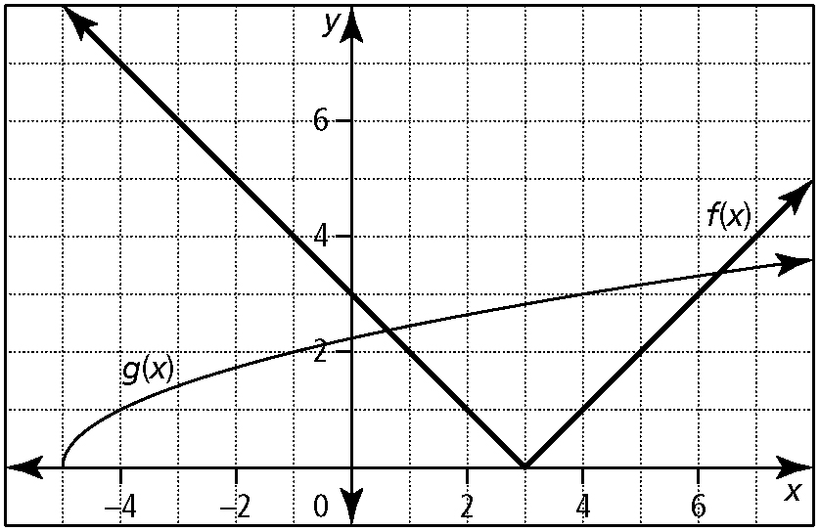

**a)** ( *f*  *g*)(4) **b)** ( *f*  *g*)(1)

**c)** ( *f*  *g*)(4) **d)** ( *f*  *g*)(5)

**8.** Sketch the graph of *h*(*x*)  ( *f*  *g*)(*x*) given the graphs of *f* (*x*) and *g*(*x*).

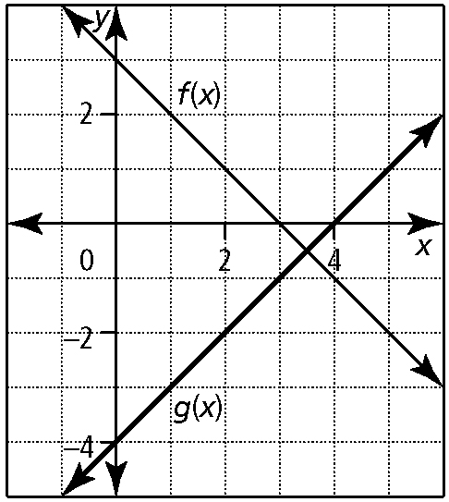

**9.** If *h*(*x*)  ( *f*  *g*)(*x*) and *f* (*x*)  3*x*  4, determine *g*(*x*).

**a)** *h*(*x*)  *x*2  5*x*  2 **b)** *h*(*x*)  

**c)** *h*(*x*)   **d)** *h*(*x*)  2*x*2  7*x*  4

**10.** The cost to rent a facility for an event is $2500 plus $14 per person. Tickets to the event cost $65.

**a)** Write equations to represent the total cost, *C*, and the total revenue, *R*, as functions of the number, *n*, of people.

**b)** Graph *C*(*n*) and *R*(*n*) on the same set of axes.

**c)** How many people must attend for the organizers of the event to break even?

**Section 1.2**

**1.** For each pair of functions, determine *h*(*x*)  *f* (*x*)*g*(*x*).

**a)** *f* (*x*)  *x*  3 *g*(*x*)  2*x*  5

**b)** *f* (*x*)  2*x*  3 *g*(*x*)  3*x*  1

**c)** *f* (*x*)   *g*(*x*)  *x*  2

**d)** *f* (*x*)   *g*(*x*)  

**2.** Consider the functions *f* (*x*)  *x*  4 and *g*(*x*)  *x*  4.

**a)** Determine the equation of *h*(*x*)  ( *f* • *g*)(*x*).

**b)** Sketch *f* (*x*), *g*(*x*), and *h*(*x*) on the same grid.

**c)** State the domain and range of *h*(*x*).

**3.** Determine *h*(*x*)  , and then state the domain and range of *h*(*x*).

**a)** *f* (*x*)  *x*  3 *g*(*x*)  2*x*  5

**b)** *f* (*x*)  2*x*  3 *g*(*x*)  3*x*  1

**c)** *f* (*x*)   *g*(*x*)  *x*  2

**d)** *f* (*x*)   *g*(*x*)  

**4.** Consider the functions *f* (*x*)  *x*2  9 and *g*(*x*)  *x*  3.

**a)** Determine the equation of the function *h*(*x*) .

**b)** Sketch the graphs of *f* (*x*), *g*(*x*), and *h*(*x*) on the same grid.

**c)** State the domain and range of *h*(*x*).

**5.** Given *f* (*x*)  *x*  1, *g*(*x*)  2*x*  1, and  
*h*(*x*)  2*x*2  7*x*  3, determine each combined function and state its domain and range.

**a)** *y*  ( *f* • *g*)(*x*) **b)** *y*  ( *f* • *h*)(*x*)

**c)** *y*  **d)** *y* 

**6.** For each pair of functions *f* (*x*) and *g*(*x*),

– determine *h*(*x*)  ( *f* • *g*)(*x*)

– sketch *f* (*x*), *g*(*x*), and *h*(*x*) on the same grid

– state the domain and range of *h*(*x*)

**a)** *f* (*x*)  *x*2  4*x*  3 *g*(*x*)  *x*  5

**b)** *f* (*x*)  *x*  4 *g*(*x*)  *x*2  16

**c)** *f* (*x*)   *g*(*x*)  

**7.** Use the graphs of *f* (*x*)  *x*2  5 and *g*(*x*)  2*x*  1 to determine each value.

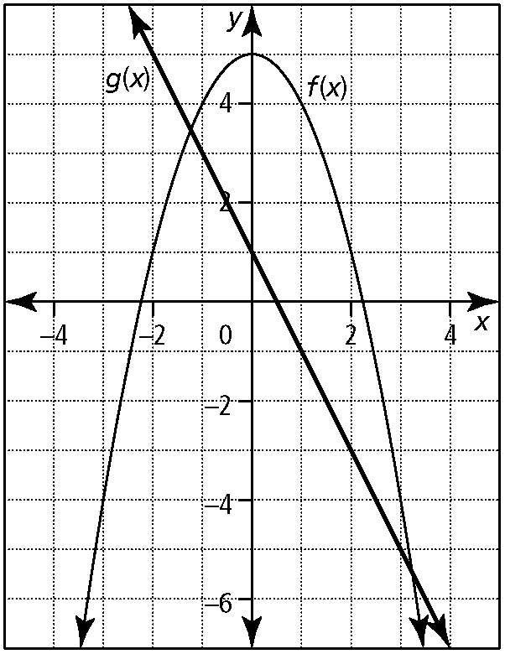

**a)** ( *f* • *g*)(1) **b)** ( *f* • *g*)(2 **c)** 

**d)**  **e)**  **f)** 

**8.** For each pair of functions *f* (*x*) and *g*(*x*),

– determine *h*(*x*)  

– sketch *f* (*x*), *g*(*x*), and *h*(*x*) on the same grid

– state the domain and range of *h*(*x*)

**a)** *f* (*x*)  *x*2  6*x*  8 *g*(*x*)  *x*  4

**b)** *f* (*x*)   *g*(*x*)  

**9.** If *h*(*x*)  and *f* (*x*)  *x*3  6*x*2  11*x*  6, determine *g*(*x*).

**a)** *h*(*x*)  *x*2  3*x*  2 **b)** *h*(*x*)  *x*2  4*x*  3

**10.** Given *f* (*x*)  *x*  1, *g*(*x*)  *x*  5, and *h*(*x*)  *x*  4, determine each combined function.

**a)** *y*  *f* (*x*)*g*(*x*)*h*(*x*) **b)** *y*  

**c)** *y*  

**Section 1.3**

**1.** Given *f* (*x*)  3*x*  5 and *g*(*x*)  2*x*  7, find each value.

**a)** *f* (*g*(1)) **b)** *f* (*g*(4)) **c)** *g*( *f* (2)) **d)** *g*( *f* (3))

**2.** Given *f* (*x*)  8  2*x* and *g*(*x*)  *x*2  3*x*  4, find each value.

**a)** *f* (*g*(1)) **b)** *f* (*g*(4)) **c)** *g*( *f* (2)) **d)** *g*( *f* (3))

**3.** Given *f* (1)  7, *f* (7)  5, *f* (3)  0, *g*(1)  3, *g*(7)  1, and *g*(5)  2, find each value.

**a)** *f* (*g*(7)) **b)** *f* (*g*(1)) **c)** *g*( *f* (1)) **d)** *g*( *f* (7))

**4.** Use the graph to find each value.

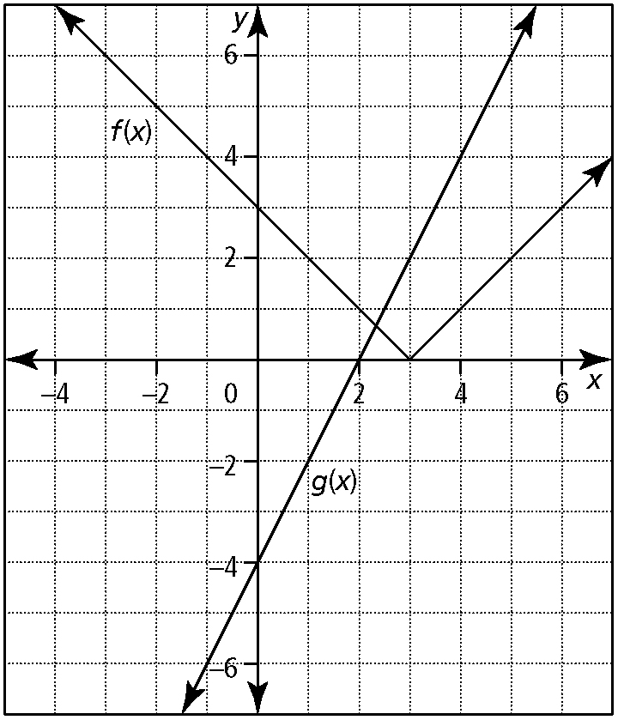

**a)** *g*( *f* (1)) **b)** *g*( *f* (2)) **c)** *f* (*g*(1)) **d)** *f* (*g*(2))

**5.** If *f* (*x*)  2*x*  9 and *g*(*x*)  *x*2  6, determine each of the following.

**a)** *f* (*g*(*a*)) **b)** *g*( *f* (*a*)) **c)** *f* (*g*(*x*))

**d)** *g*( *f* (*x*)) **e)** *f* (*f* (*x*)) **f)** *g*(*g*(*x*))

**6.** Consider *f* (*x*)  *x*2  5 and *g*(*x*)  

**a)** Determine *y*  *f* (*g*(*x*)).

**b)** Sketch the graph of *y*  *f* (*g*(*x*)).

**c)** State the domain and range of *y*  *f* (*g*(*x*)).

**7.** Given *f* (*x*)  and *g*(*x*)  *x*  5, sketch the graph of each composite function. Then, determine the domain and range of each composite function.

**a)** *f* (*g*(*x*)) **b)** *g*(*f* (*x*))

**8.** For each pair of functions, *f* (*x*) and *g*(*x*), determine *f* (*g*(*x*)) and *g*(*f* (*x*)).

**a)** *f* (*x*)  3*x*  1 *g*(*x*)  *x*2  2

**b)** *f* (*x*)  *x*2  4 *g*(*x*)  5*x*  7

**c)** *f* (*x*)  *x*2  *x* *g*(*x*)  *x*2  *x*

**d)** *f* (*x*)  *x*2  9 *g*(*x*)  

**9.** If *h*(*x*)  ( *f*  *g*)(*x*), determine *g*(*x*).

**a)** *h*(*x*)  *x*  4 and *f* (*x*)  *x*2

**b)** *h*(*x*)  *x*2  6*x*  5 and *f* (*x*)  *x*2  4

**10.** A manufacturer’s weekly production of office chairs can be modelled by the function *N*(*t*)  100  25*t*, where *t* is the time in years since 2001, and *N* is the number of chairs. The size of the manufacturer’s workforce can be modelled by the composite function *W*(*N*) .

**a)** Write an equation that represents the size of the workforce as a function of time.

**b)** Determine the domain and range of the function from part a).

**c)** What was the size of the workforce in 2011? How many office chairs were manufactured in that year?

**Answers Section 1.1**

**1. a)** *h*(*x*)    12 **b)** *h*(*x*)  7*x*  4 **c)** *h*(*x*)  2*x*2  4*x*  3

**d)** *h*(*x*)  *x*2  *x*  17 **2.** **a)** *h*(*x*)  *x*2  3*x*  4

|  |  |
| --- | --- |
| **b)** | **c)** domain: {*x* | *x* ∈ R}; range: {*y* | *y* ≥ 6.25,∈ R}  **3.** **a)** *h*(*x*)  10   **b)** *h*(*x*)  *x*  13  **c)** *h*(*x*)  *x*2  4*x*  8  **d)** *h*(*x*)  *x*2  8*x*  10 |

**4. a)** *h*(*x*)  *x*2  *x*  1

|  |  |
| --- | --- |
| **b)** | **c)** domain: {*x* | *x* ∈ R}; range: {*y* | *y* ≥ 0.75, *y*∈ R}  **5. a)** *y* = *x*2    6; domain: {*x* | *x* ≥ 2, *x* ∈ R};  range: {*y* | *y* ≥ 2, *y* ∈ R} |

**b)** *y* =   2*x*  1; domain: {*x* | *x* ≥ 2, *x* ∈ R};   
range: {*y* | *y* ≤ , *y* ∈ R} Note: The actual range is difficult to determine from the graph, and the best estimate for range may be {*y* | *y* ≤ 3, *y* ∈ R}.

**c)** *y* = 2*x*    1; domain: {*x* | *x* ≥ 2, *x* ∈ R};   
range: {*y* |  ≤ *y*, *y* ∈ R} Note: The actual range is difficult to determine from the graph, and the best estimate for range may be {*y* | 3≤ *y*, *y* ∈ R}

**d)** *y* = *x*2  2*x*  7; domain: {*x* | *x* ∈ R}; range: {*y* | *y* ≥ 8, *y* ∈ R}

**6. a)** *h*(*x*)  *x*2  4*x*  2; 10 **b)** *m*(*x*)  *x*2  4*x*  12; 15

**c)** *p*(*x*)  *x*2  4*x*  2; 3 **7. a)** 4 **b)** 6 **c)** 8 **d)** 8

|  |  |
| --- | --- |
| **8.** | **c)** 50 people  **9. a)** *g*(*x*)  *x*2  2*x*  2  **b)** *g*(*x*)   **c)** *g*(*x*)  9 **d)** *g*(*x*)  2*x*2  10*x* 8  **10. a)** *C*(*n*)  2500  14*n*  *R*(*n*)  65*n* |
| **b)** |  |

**Section 1.2**

**1. a)** *h*(*x*)  2*x*2  *x*  15 **b)** *h*(*x*)  6*x*2  7*x*  3

**c)** *h*(*x*)  *x*  2 **d)** *h*(*x*)  

**2. a)** *h*(*x*)  *x*2  16

|  |  |
| --- | --- |
| **b)** |  |

**c)** domain: {*x* | *x* ∈ R}; range: {*y* | *y* ≥ 16, *y* ∈ R}

**3. a)** *h*(*x*)  ; domain: ;

range: {*y* | *y* ≠ , *y* ∈ R}

**b)** *h*(*x*)  ; domain: ;   
range: {*y* | *y* ≠ , *y* ∈ R}

**c)** *h*(*x*)  ; domain: {*x* | *x* ≥ 4, *x* ∈ R};  
range: {*y* | 0 ≤ *y* ≤ , *y* ∈ R}

**d)** *h*(*x*)  ; domain: {*x*| 1≤ *x* < 3, *x* ∈ R};   
range: {*y* | 0 ≤ *y*, *y* ∈ R} **4. a)** *h*(*x*)  *x*  3, *x* ≠ 3

|  |  |
| --- | --- |
| **b)** | **c)** domain: {*x* | *x* ≠ 3, *x* ∈ R};  range: {*y* | *y* ≠ 6, *y* ∈ R} |

**5. a)** *y*  2*x*2  3*x*  1; domain: {*x* | *x* ∈ R};   
range: {*y* | *y* ≥ 0.125, *y* ∈ R}

**b)** *y*  2*x*3  9*x*2  10*x*  3;   
domain: {*x* | *x* ∈ R}; range: {*y* | *y* ∈ R}

**c)** *y*  ; domain: {*x* | *x* ≠ 1, *x* ∈ R};   
range: {*y* | *y* ≠ 2, *y* ∈ R}

**d)** *y*  *x*  3; domain: {*x* | *x* ≠ , *x* ∈ R};   
range: {*y* | *y* ≠ 2.5, *y* ∈ R}

**6. a)** *h*(*x*)  *x*3  *x*2  17*x*  15

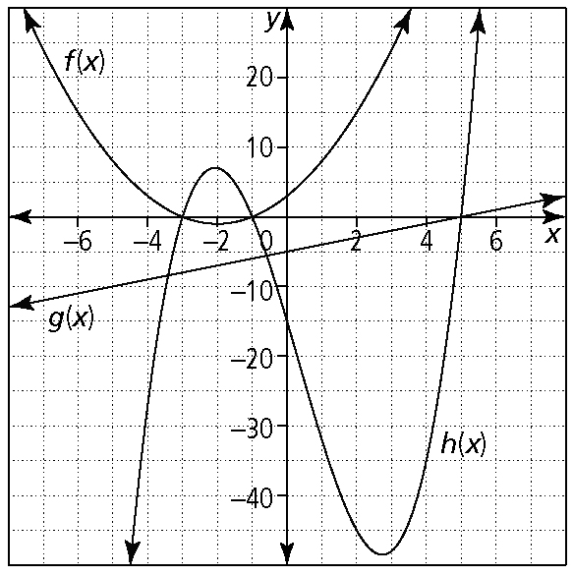

domain: {*x* | *x* ∈ R}; range: {*y* | *y* ∈ R}

**b)** *h*(*x*)  *x*3  4*x*2  16*x*  64

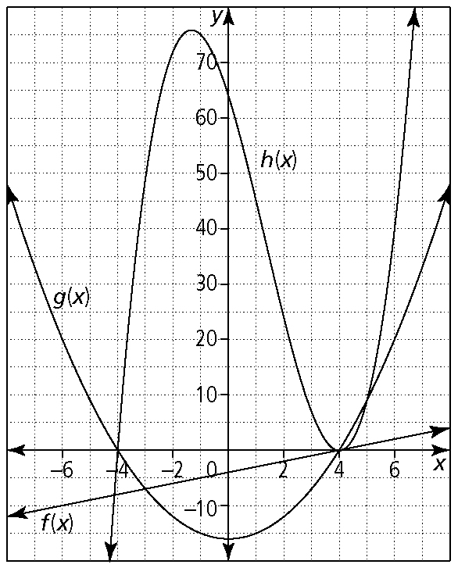

domain: {*x* | *x* ∈ R}; range: {*y* | *y* ∈ R}

**c)** *h*(*x*)  

domain: {*x* | *x* ≠ 1, 3, *x* ∈ R}; range: {*y* | *y* > 0 or *y* ≤ , *y* ∈ R}

**7. a)** 12 **b)** 3 **c)** 4 **d)** 0.8 **e)** 0.2 **f)** 5

**8. a)** *h*(*x*)  *x*  2

domain: {*x* | *x* ≠ 4, *x* ∈ R}; range: {*y* | *y* ≠ 2, *y* ∈ R}

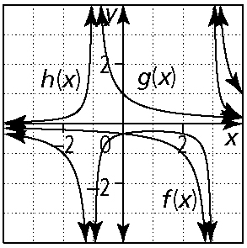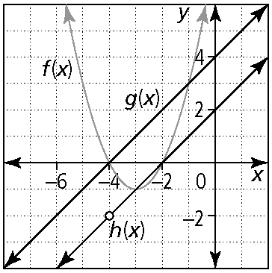

**b)** *h*(*x*)  

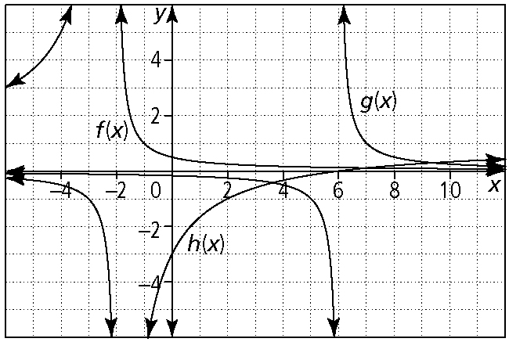

domain: {*x* | *x* ≠ 2, 6, *x* ∈ R}; range: {*y* | *y* ≠ −2, 1,or 6, *y* ∈ R}

**9. a)** *g*(*x*)  *x*  3 **b)** *g*(*x*)  *x*  2 **10. a)** *y*  *x*3  8*x*2  11*x*  20

**b)** *y*   **c)** *y*  

**Section 1.3**

**1. a)** 10 **b)** 40 **c)** 29 **d)** 1 **2. a)** 8 **b)** 8 **c)** 184 **d)** 14

**3. a)** 7 **b)** 0 **c)** 1 **d)** 2 **4. a)** 4 **b)** 6 **c)** 5 **d)** 3

**5. a)** *y* = 2*a*2  3 **b)** *y* = 4*a*2  36*a*  87 **c)** *y* = 2*x*2  3

**d)** *y* = 4*x*2  36*x*  87 **e)** *y* = 4*x*  27 **f)** *y* = *x*4  12*x*2  42

**6. a)** *y*  *x*  3

|  |  |
| --- | --- |
| **b)** |  |

**c)** domain: {*x* | *x* ≥ 2, *x* ∈ R}; range: {*y* | *y* ≥ 5, *y* ∈ R}

|  |  |
| --- | --- |
| **7. a)** |  |

domain: {*x* | *x* ≥ 7, *x* ∈ R}; range: {*y* | *y* ≥ 0, *y* ∈ R}

|  |  |
| --- | --- |
| **b)** |  |

domain: {*x* | *x* ≥ 2, *x* ∈ R}; range: {*y* | *y* ≥ 5, *y* ∈ R}

**8. a)** *f* (*g*(*x*))  3*x*2  5; *g*(*f* (*x*))  9*x*2  6*x*  3

**b)** *f* (*g*(*x*))  25*x*2  70*x*  45; *g*(*f* (*x*))  5*x*2  13

**c)** *f* (*g*(*x*))  *x*4  2*x*3  *x*2  *x*; *g*(*f* (*x*))  *x*4  2*x*3  *x*2  *x*

**d)** *f* (*g*(*x*))  *x*  5; *g*(*f* (*x*)) 

**9. a)** *g*(*x*)   **b)** *g*(*x*)  *x*  3

**10. a)** *W*(*N*(*t*))   **b)** domain: {*t* | *t* ≥ 0, *t* ∈ R};   
range: {*W* | *W* ≥ 30, *W* ∈ R} **c)** 57 workers; 350 chairs