PC 12 **Chapter 1 Transformations Review**

MULTIPLE CHOICE

1. A function is graphed. If , then the graph of is the same as the graph of
2. reflected on the line  c. reflected on the -axis
3. reflected on the -axis d. the reciprocal of 
4. The graph of a function is a parabola opening upward, with its vertex on -axis. The graph of a new function  , where will have
5. The same domain and range as  c. a different domain but same range as 
6. The same domain but a different range than  d. a different domain and a different range than 
7. As a result of the transformation of the graph of into the graph of , the point (3, 27) becomes the point (6, ). The value of is
8. 31 b. 30 c. 23 d. 24
9. If is replaced by in the equation , then the graph of  will be stretched
10. Horizontally about the -axis by a factor of  c. Vertically about the -axis by a factor of 
11. Horizontally about the -axis by a factor of 2 d. Vertically about the -axis by a factor of 2
12. Given the graph of  below, which of the following graphs represents the transformed function ? a. c.

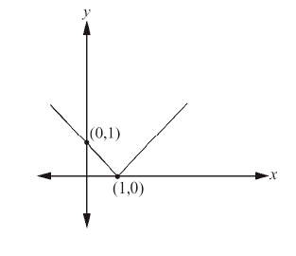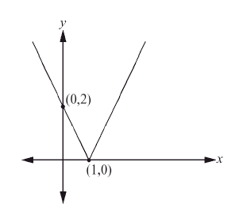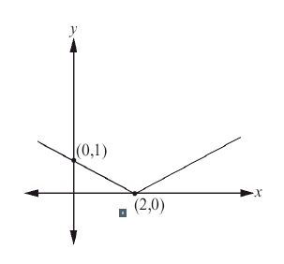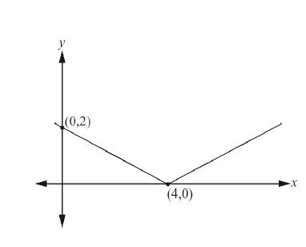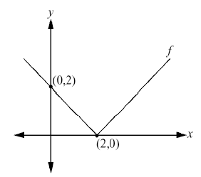

b. d.

1. The graphs of was transformed to . Which of the following statements describes the transformation?
2. Translation 4 units to the right and 3 up c. The point (*x, y*) has been translated to (*x + 3, y +4*)
3. 3 units to the left and 4 down d. The point (*x, y*) has been translated to (*x - 3, y - 4*)
4. Which of the following transformations of result in  ?
5. 
6. 
7. 
8. 

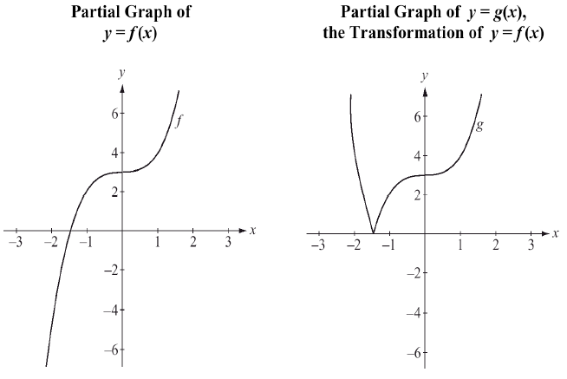

1. Given the graph of , which of the following is the graph of ?

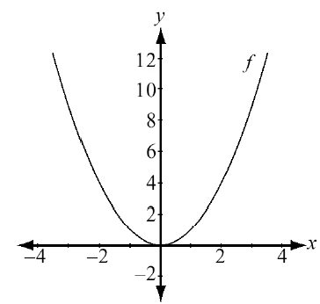

1. c.

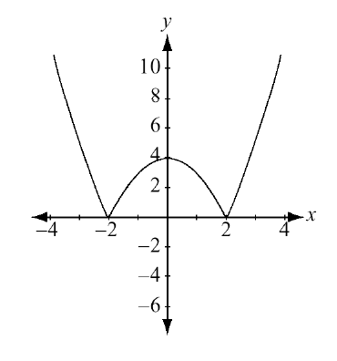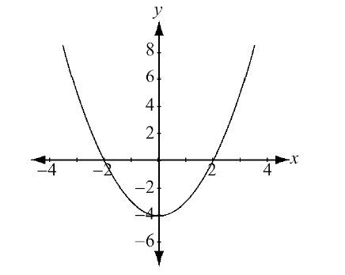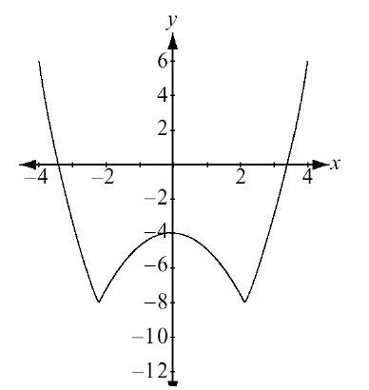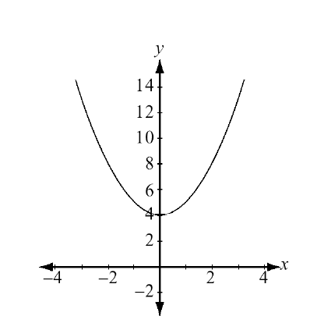

b. d.

1. The graph of , where , is reflected in the y-axis. This produced the same results as would translating the graph of to the right by ______ units.
2. 4 units b. 1 unit c. 8 units d. 5 units
3. Given  below, determine the range of .
4. 
5. 
6. 
7. 

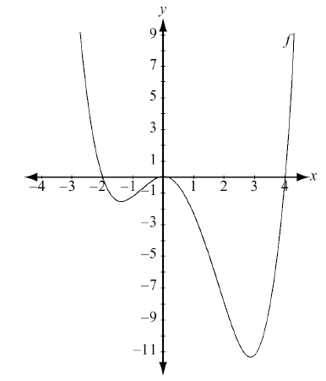

1. The function and its reflection are shown below. An expression for this reflection is
2. 
3. 
4. 
5. 

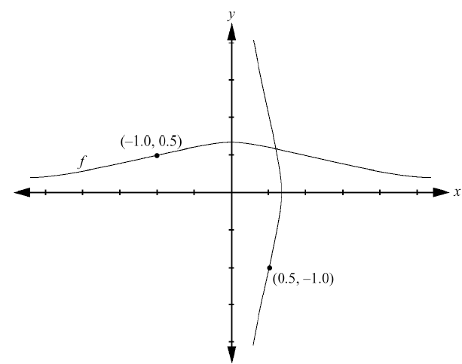

1. How is the graph of related to the graph of ?
2. has been translated 3 up c. has been translated 3 left
3. has been translated 3 down d. has been translated 3 right
4. Which equation represents the graph of  after it is reflected in the line ?
5.  b.  c.  d. 
6. If the graph of the function is horizontally expanded by a factor of 3 and then translated 2 units to the right, determine the equation of this new function.
7.  b.  c.  d. 
8. If (4, 12) is a point on the graph , what must be a point on the graph of ?
9. (4, -9) b. (4, 15) c. (2, -9) d. (2, -15)
10. The graph of  is shown below on the left. Which equation represents the graph shown on the right?

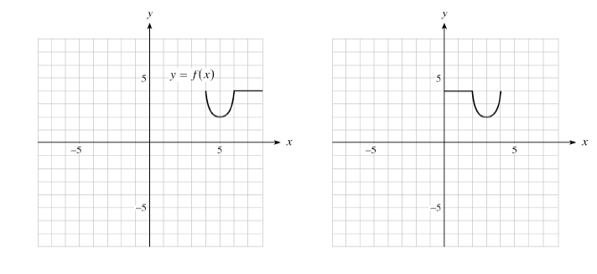

1. 
2. 
3. 
4. 
5. Which equation represents the graph of  after it is reflected in the x- axis?
   1.  b.  c.  d. 
6. If , determine the equation of , the inverse of .
7.  b.  c.  d. 
8. The graph of is graphed below on the left. Determine the equation of the function on the right.
9. 
10. 
11. 
12. 

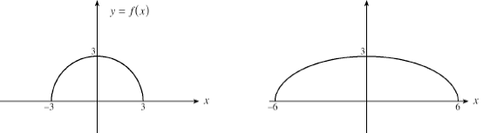

1. If the range of is , determine the range of 
2.  b.  c.  d. 
3. If the point (4, -9) is on the graph of , which of the following points must be on the graph of ?
4. (3, -3) b. (9, -3) c. (9, 27) d. (3, -27)
5. The graph of is a reflection of the graph of in which line?
6. the y axis b. the x axis c. the line  d. the line 
7. The point (6, 1) is on the graph of the function . Which point must be on the graph of the function 
8. (0, 12) b. (-6, 6) c. (6, 1) d. (0, -6)
9. If the graph  is translated 5 units down, determine the equation of the transformed graph.
10.  b.  c.  d. 
11. How is the graph of related to the graph of ?
12. expanded vertically by a factor of 4 c. expanded horizontally by a factor of 4
13. compressed vertically by a factor of  d. compressed horizontally by a factor of 
14. Determine the equation that will cause the graph of to expand vertically by a factor of 3 and reflect about the x axis.
15.  b.  c.  d. 
16. If the graph of is horizontally compressed by a factor of , and then reflected in the y-axis, determine the equation of the new graph.
17.  b.  c.  d. 

**ANSWERS**

1. C
2. A
3. A
4. D
5. D
6. C
7. B
8. A
9. C
10. B
11. B
12. B
13. A
14. B
15. C
16. B
17. B
18. B
19. A
20. C
21. A
22. B
23. D
24. C
25. D
26. A
27. B