**Chapter 4 Review Pt.1 Section 4.1**

**EXPONENTIAL FUNCTIONS**

**1.** State which are exponential. Explain your answer.

*y*  *x*7 *y*  0.5*x y*  4*x* 

**2.** Is *y*  (2)*x* an exponential function? Explain**.**

**3.** Graph each function and identify the following:

**•** the *x*-intercept and *y*-intercept

**•** whether the function is increasing or decreasing

**•** the domain and range

**•** the equation of the horizontal asymptote

**a)** *y*  3*x* **b)** *y*  (0.5)*x*

**4. a)** Graph *y*  2*x*, *y*  3*x*, and *y*  4*x* on the same grid.

**b)** For what *x*-value do all three functions have the same *y*-value? What is the *y*-value?

**c)** Graph the functions , , and  on the same grid as you used for part a). Explain what you notice about these functions in relation to each other, and the functions you graphed in part a).

**5.** Determine the equation of each graph.

|  |  |
| --- | --- |
| **a)** |  |
| **b)** |  |
| **c)** |  |
| **d)** |  |

**6.** Atmospheric pressure varies with altitude above the surface of Earth. For altitudes up to 10 km, the pressure, *P*, in kilopascals (kPa), is given by *P*  100*e*0.139*a*, where *e* is the base (approximately equal to 2.7183) and *a* is the altitude in kilometres. What would the pressure be at 5 km above the surface of Earth? Express your answer to the nearest kilopascal.

**7.** A sample of water contains 200 g of pollutants. Each time the sample is passed through a filter, 20% of its pollutants are removed.

**a)** Write a function that relates the amount of pollutant, *P*, that remains in the sample to the number of times, *t*, the sample is filtered.

**b)** Graph the function.

**c)** Determine an expression that gives the amount of pollutants still in the water after it passes through 5 filters. How many grams are there after 5 filters, rounded to the tenth of a gram?

**8.** Iodine-126 has a half-life of 13 days.

**a)** Write an exponential function to represent the radioactive decay of 100 g of Iodine-126.

**b)** Graph the function.

**c)** How much Iodine-126 will be left after 50 days? Round your answer to hundredths of a gram.

**d)** Describe how you might use your graph to calculate the length of time it will take for 100 g of Iodine-126 to decay to 15 g. How long with this decay take, to the nearest half day?

**9.** The population of rabbits in a park is increasing by 70% every 6 months. Presently there are 200 rabbits in the park.

**a)** What will the base be for the exponential function that represents this scenario? Explain.

**b)** Write an exponential function that represents this scenario. Use *P* to represent the rabbit population, and *t* to represent the time in months.

**c)** How many rabbits will there be in 15 months?

**10.** Jennifer and Brody are going scuba diving. In the particular spot they are diving, the intensity of light is reduced by 2% for each metre that they descend below the surface of the water.

**a)** Write the exponential decay model that relates the amount of light, *L*, that is available at each depth, *d*, in 1-m increments.

**b)** What are the domain and range?

**c)** Graph the function for an appropriate domain.

**d)** Use your graph to determine at what depth, to the nearest metre, the intensity of light is only 10% of the intensity at the surface.

**Section 4.2**

**1.** Match each function with the corresponding transformation of *y*  4*x*.

**a)** *y*  4*x* **b)** *y*  4*x*  **c)** *y*  4*x*  2 **d)** *y*  4*x*  2

**A** reflection in the *x*-axis **B** reflection in the *y*-axis

**C** vertical stretch **D** horizontal stretch

**E** translation down **F** translation up

**G** translation left **H** translation right

**2.** Without using technology, match each function with the corresponding graph.

**a)**  **b)** **c)** **d)**

|  |  |
| --- | --- |
| **A** | **B** |

**C D**

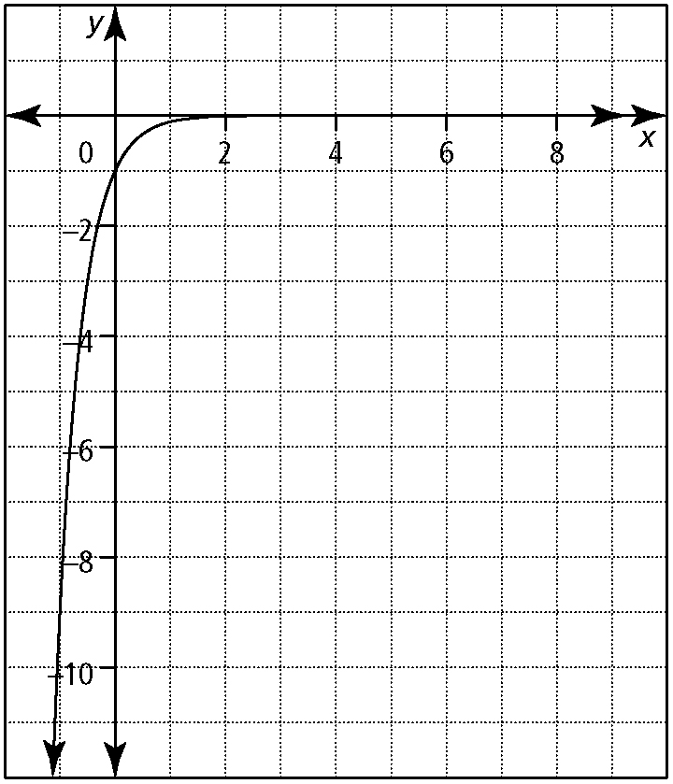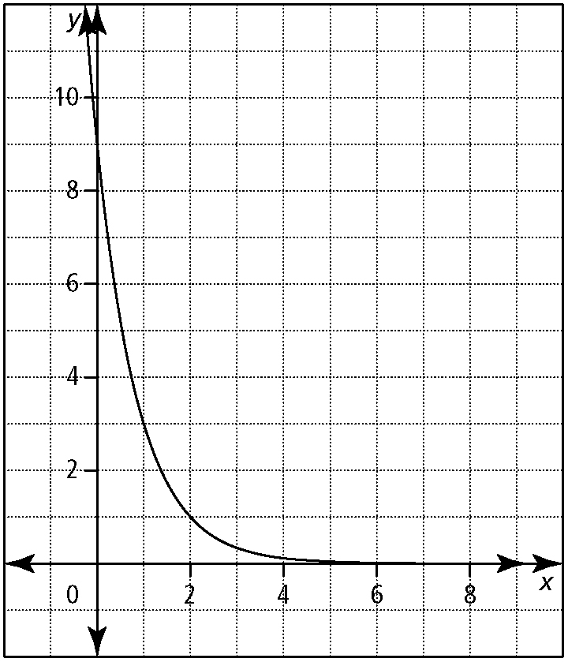

**3.** Complete the following table to show the progression of the transformation.

|  |  |  |  |
| --- | --- | --- | --- |
| ***y*  5*x*** | ***y*  5*x*** |  |  |
|  |  |  |  |
|  |  |  |  |
| (0, 1) |  |  |  |
| (1, 5) |  |  |  |
| (2, 25) |  |  |  |

**4.** State the parameters *a*, *b*, *h*, and *k*. Describe the transformation that corresponds to each parameter.

**a)** *f*(*x*)  4(2)*x*  6 **b)** *g*(*x*)  (0.3)*x*  4

**c)**  **d)** 

**5.** Sketch each of the following functions. Identify the corresponding *y*-value for each given value of *x*.

**a)** *y*  (4)0.5(*x*  1)  7; *x*  1, *x*  3, *x*  5

**b)** *y*  3(2)2(*x*  5); *x * 5, *x*  4.5, *x*  4

**c)** ; *x*  6, *x*  7, *x*  8

**6.** Write each transformed function in the form *y*  *a*(*c*)*b*(*x*  *h*)  *k*.

**a)** *f*(*x*)  (0.5)*x* after it has been vertically stretched by a factor of 3, reflected over the *y*-axis, and translated 4 units left and 3 units down

**b)** *g*(*x*)  3*x* after it has been horizontally stretched by a factor of one half, reflected over the *x*-axis, and translated 7 units up

**c)** *h*(*x*)  2*x*, *y*  4*h*(2(*x*  3))  5

**d)** , 

**7.** For the following exponential functions, state the

• domain and range

• equation of the horizontal asymptote

• *x*-intercept and *y*-intercept

**a)** *f*(*x*)  6(3)*x*  2 **b)** *g*(*x*)  0.5(4)2*x*  4

**c)** 

**8. a)** Given *y*  3*x*, list the parameters of the transformed exponential function *y*  0.5(3)2(*x*  4)  7.

**b)** Describe how each parameter in part a) transforms the graph of the original function, *y*  3*x*.

**c)** The following points lie on the graph of *y*  3*x*: (0, 1), (1, 3), (2, 9). Write the transformed point that corresponds to each for the function *y*  0.5(3)−2(*x*  4)  7.

**9.** The estimated population of a city in 2011 was 35 000, with an annual rate of increase of about 2.4%.

**a)** What is the growth factor for this city?

**b)** Graph the population growth of this city from 2011 until 2021.

**c)** Estimate the population in 2016.

**10.** The pressure of Earth’s atmosphere is 14.7 lb/in.2 at sea level. Pressure decreases by about 20% for each mile of ascent up to an altitude of about 50 miles.

**a)** Graph this situation up to 10 mi.

**b)** Estimate the pressure at an altitude of 5 mi to the nearest pound per square inch

**Section 4.3**

**1.** Write each expression as a single power of 2.

**a)** 0.5 **b)**  **c)** 512 **d)** 

**2.** Rewrite the expressions in each pair so that they have the same base.

**a)** 25 and  **b)** 27 and 

**c)** 0.25 and 8 **d)** 

**3.** Solve. Check your answer using substitution.

**a)** 34*x*(3)  272*x* **b)** 

**c)**  **d)** 2*x*  1  (128*x*)(2*x*)

**4.** Solve. **a)** 16*x*  1  81  *x* **b)** 

**c)**  **d)** 

**5.** Solve for *t*. Round your answers to two decimal places.

**a)** 800  500(1.03)*t* **b)** 

**c)** 3*t*  2*t*  4 **d)** 5*t*  21  *t*

**6.** Write an exponential expression that will determine the value, *V*, of the investment, *t*, in years.

**a)** $3000 is invested at 5.2% per year compounded semi-annually

**b)** $2500 is invested at 4% per year compounded quarterly

**c)** $8000 is invested at 6% per year compounded monthly

**d)** $6300 is invested at 2.1% per year

**7.** If $5000 is invested at 7.2% per year compounded monthly, how long will it take for the investment to increase to $8000? Answer in years to two decimals.

**8. a)** Determine how much an investment of $3500 will be worth after 4 years if it is compounded semi-annually at a rate of 5% per year.

**b)** How long will it take for the investment to double in value? Answer in years to two decimal places.

**9.** Malcolm bought a new car for $24 000. Every year it will depreciate in value by 8%.

**a)** How much will the car be worth after 5 years?

**b)** How long will it take for the car to be worth a quarter of its original value? Give your answer to two decimal places.

**10. a)** Jamie borrows $6000 from the bank at a rate of 8% per year compounded monthly. How much would he owe at the end of one month, if he does not make his first payment?

**b)** Steven borrows $6000 on his credit card at the rate of 19.99% per year compounded monthly. How much would he owe at the end of one month, if he does not make his first payment?

**Answers Section 4.1**

**1.** *y*  0.5*x* and *y*  4*x* are exponential since they in the form *y*  *cx*, where *c* is a constant greater than 0 and *x* is a variable.

**2.** No. The constant is not a value greater than zero, so the graph is not a continuous decreasing or increasing function.

|  |  |  |  |
| --- | --- | --- | --- |
| **3. a)** | | *x*-intercept: does not exist, *y*-intercept: 1; function is increasing; domain:{*x* | *x* ∈ R}, range: {*y* | *y*  0, *y* ∈ R}; *y*  0 | |
| **b)** | *x*-intercept: does not exist, *y*-intercept: 1; function is decreasing; domain: {*x* | *x* ∈ R}, range: {*y* | *y*  0, *y* ∈ R}; *y*  0 | |
| **4. a)**  The graphs have the same *y*-intercept: *y*  1. These graphs are the horizontal reflections of the graphs in part a). | | **b)** 0; 1 **c)** | |
|  |  | |

**5. a)**  **b)** *y*  6*x*  **c)** *y*  2*x* **d)**  **6.** 50 kPa

**c)** 200(0.80)5  65.5

**8. a)**  **b)**

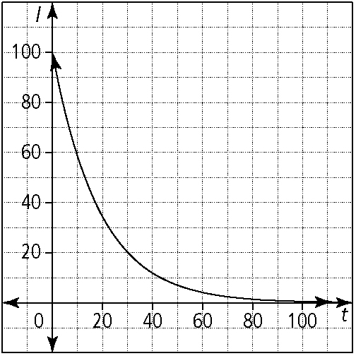

**7. a)** *P*(*t*)  200(0.80)*t*

|  |  |  |
| --- | --- | --- |
| **b)** |  | |
| **c)** 6.95 g **d)** graph *f*(*t*)  15 on the same axes as the original graph and find the intersection point; 35.5 days | |  | |

**9. a)** 1.7; the population is increasing by 70%, so 100%  70%

**b)**  **c)** ≈753

|  |  |
| --- | --- |
| **10. a)** *L*(*d*)  (0.98)*d*  **c)**  **b)** domain: {*d* | *d* ≥ 0, *d* ∈ R}, range: {*L* | 0 < *L* ≤ 1, *L* ∈ R}  **d)** 114 m |  |

**Section 4.2**

**1. a)** A **b)** B **c)** E **d)** H **2. a)** C **b)** A **c)** D **d)** B

**3.**

|  |  |  |  |
| --- | --- | --- | --- |
| ***y*  5*x*** | ***y*  5*x*** |  |  |
|  |  |  |  |
|  |  |  |  |
| (0, 1) | (0, 1) |  |  |
| (1, 5) | (1, 5) |  |  |
| (2, 25) | (2, 25) |  |  |

**4. a)** *a*  4: vertical stretch by a factor of 4, *b*  1: no change, *h*  0: no change, *k*  6: translation 6 units up

**b)** *a*  1: reflection over the *x*-axis, *b*  1: no change, *h*  4: translation 4 units right, *k*  0: no change

**c)** : vertical stretch by a factor of , *b*  4: horizontal stretch by a factor of , *h*  9: translation 9 right, *k*  8: translation 8 down

**d)** : vertical stretch by a factor of , : reflection over the *y*-axis and horizontal stretch by a factor of , *h*  2: translation 2 units left, : translation 1.75 units up

|  |  |
| --- | --- |
| **b)** |  |

|  |  |  |  |
| --- | --- | --- | --- |
| **5. a)** | |  | |
|  | **6 a)** *y*  3(0.5)(*x*  4)  3 **b)** *y*  (3)2*x*  7  **c)** *y*  4(2)2(*x*  3)  5 **d)**  **7.** **a)** domain: {*x* | *x* ∈ R}, range: {*y* | *y*  2, *y* ∈ R}; *y*  2; *x*-intercept  (1, 0), *y*-intercept (0, 4) | |
| **c)** |  | |

**b)** domain: {*x* | *x* ∈ R}, range: {*y* | *y*  4, *y* ∈ R};

*y*  4; *x*-intercept (0.75, 0), *y*-intercept (0, 3.5)

**c)** domain: {*x* | *x* ∈ R}, range: {*y* | *y*  0, *y* ∈ R};

*y*  0; *x*-intercept does not exist, *y*-intercept (0, 2)

**8. a)** *a*  0.5, *b*  2, *h*  4, *k*  7 **b)** vertical stretch by a factor of 0.5, a reflection over the *y*-axis, a horizontal stretch by a factor of , a horizontal translation 4 units left, and a vertical translation 7 units up **c)** (0, 1) becomes (4, 7.5), (1, 3) becomes (4.5, 8.5), (2, 9) becomes (5, 11.5) **9. a)** 1.024

**c)** ≈39 400 (exactly 39 406)

|  |  |
| --- | --- |
| **10 a)** |  |

**b)** ≈5 lb/in.2 (exactly 4.8 lb/in.2)

|  |  |
| --- | --- |
| **b)** |  |

**Section 4.3**

**1. a)** 21 **b)**  **c)** 29 **d)** 220 **2. a)** 52 and 53 **b)** 33 and 

**2c)** 22 and 23 **d)**  **3. a)** 0.5 or  **b)** 3 **c)** 2 **d)** 

**4. a)** ≈ −0.14 **b)** 3 **c)** 17 **d)**   1.2 **5. a)** 15.90

5**b)** 1.77 **c)** 6.84 **d)** –0.76 **6. a)** *V*  3000(1.026)2*t*

**b)** *V*  2500(1.01)4*t* **c)** *V*  8000(1.005)12*t* **d)** *V*  6300(1.021)*t*

**7.** 6.55 years **8. a)** $4264.41 **b)** 14.04 years

**9. a)** $15 817.96 **b)** 16.63 years **10. a)** $6040 **b)** $6099.95