**Chapter 4 Review Pt.2 Section 4.1**

**LOGARITHMS**

**1.** Evaluate each expression without a calculator.

**a)** log8 64 **b)** log 1000 **c)** log2 8 **d)** log3 81

**e)** log7 1 **f)** log4 2 **g)** log 0.01 **h)** log4 

**2.** Express in logarithmic form.

**a)** 35  243 **b)**  **c)** 2−2  0.25 **d)** 52*m*  *n*  4

**3.** Express in exponential form.

**a)** log4 64  3 **b)** log4 8  

**c)** log 10 000  4 **d)** log6 (*x* − 2)  *y*

**4.** Determine the value of *x*.

**a)** log4 *x*  2 **b)** log5 *x*  −1

**c)** log*x* 81  4 **d)** log4 

**5. a)** Sketch the exponential function *y*  3*x*.

**b) S**ketch the graph of the inverse of *y*  3*x*.

**c)** Explain the relationship between the two functions.

**6. a)** State the equation of the inverse of.

**b)** Sketch the graph of the inverse.

**c)** Identify the domain, range, and intercepts of the inverse graph.

**d)** Determine the equations of any asymptotes.

**7.** Identify the following characteristics of the inverse graph of each function.

**i)** the domain and range **ii)** the *x*-intercept, if it exists

**iii)** the *y*-intercept, if it exists

**iv)** the equation of the asymptote

|  |  |
| --- | --- |
| **a)** |  |
| **b)** |  |

**8.** Determine the following values to one decimal place.

**a)** log2 60 **b)** log3 30 **c)** log5 80 **d)** log 35

**9. a)** Determine the *x*-intercept of *y*  log4 (*x* − 3).

**b)** Determine the *y*-intercept of *y*  log6 *x* − 5.

**10.** The point  is on *f* (*x*)  log*c* *x*. The point (*k*, 64) is on the inverse, *y*  *f* −1(*x*). Determine *k*.

**Section 4.2**

**1.** Describe how the graph of each log function can be obtained from the graph of *y*  log4 *x*.

**a)** *y*  log4 (*x*  8)  1 **b)** *y*  log4 (3*x*)

**c)** 

**2. a)** Sketch the graph of *y*  log2 *x.* Then, apply, in order, the following transformations.

* Stretch hor. by a factor of 3 about the *y*-axis.
* Translate 5 units to the right.

**b)** Write the equation of the final transformed image.

**3. a)** Sketch the graph of *y*  log6 *x*. Then, apply, in order, the following transformations.

* Reflect in the *x*-axis.
* Translate vertically 2 units down.

**b)** Write the equation of the final transformed image.

**4.** Sketch the graph of each function.

**a)** *y*  log3 (*x*  2)  7 **b)** *y*  log2 ( (*x*  5))  3

**c)** *y*  4 log5 (2*x*)  1

**5.** Identify the following characteristics of the graph of each function.

**i)** the equation of the asymptote

**ii)** the domain and range

**iii)** the *y*-intercept **iv)** the *x*-intercept

**a)** *y*  log5 (*x*)  3 **b)** *y*  3 log2 (2(*x*  4))

**c)** *y*  4 log7 (*x*  2)  1 **d)** 

**6.** In each graph, the solid curve is a stretch and/or reflection of the dashed curve. Write the equation of each solid graph.

|  |  |
| --- | --- |
| **a)** |  |
| **b)** |  |
| **c)** |  |
| **d)** |  |

**7.** Describethe transformations that could be applied to *y*  log3 *x* to obtain the graph of each function.

**a)** *y*  2 log3 (5(*x*  4))  7 **b)** *y*  0.2 log3 ((*x*  1))  3

**8.** The graph of *y*  log2 *x* has been transformed to *y*  *a* log2 (*b*(*x*  *h*)  *k*. Determine the values of *a*, *b*, *h,* and *k* for each set of transformations. Write the equation of the transformed function.

**a)** a reflection in the *y*-axis and a translation 5 units right and 2 units down

**b)** a vertical stretch by a factor of  about the *x*-axis and a hor. stretch about the *y*-axis by a factor of 4

**c)** a vertical stretch about the *x*-axis by a factor of , a horizontal stretch about the *y*-axis by a factor of , a reflection in the *x*-axis, and a translation of 7 units left and 2 units up

**9.** Describe how the graph of each logfunction can be obtained from the graph of *y*  log7 *x*.

**a)** *y*  5 log2 (3*x*  15)  7

**b)** *y*  0.25 log2 (2  *x*)  5 **c)** 2(*y*  7)  log2 (*x*  1)

**10. a)** Only a horizontal translation has been applied to the graph of *y*  log4 *x* so that thetransformed image passes through the point (6, 2). Determine the equation of the transformed image.

**b)** A vertical stretch is applied to the graph of *y*  log3 *x* so that the graph of the transformed image passes through the point (2, 12). Determine the equation of the transformed image.

**Section 4.3**

**1.** Write each expression in terms of the individual logarithms of *x*, *y*, and *z*.

**a)**  **b)** 

**c)**  **d)** 

**2.** Simplify and evaluate each expression.

**a)**  **b)** 2 log2 4  log2 5  log2 10

**c)** log5 25 **d)** 

**3.** Write each as a single logarithm in simplest form.

**a)** log4 *x*  2 log4 *y* **b)** log6 *x*  3 log6 *y*  4 log6 *z*

**c)**  **d)** 2  3 log *x*  log *y*

**4.** Evaluate each of the following.

**a)** If log5 *x*  25, determine the value of .

**b)** Determine the value of log*n* *ab*2  
if log*n* *a*  5 and log*n* *b*  3.

**c)** If log *c*  3, evaluate log 10*c*2.

**d)** If loga *x*  3 and loga *y*  4, evaluate .

**5.** Simplify. **a)**  **b)** 

**6.** If log5 9  *k*, write an algebraic expression in terms of *k* for each of the following.

**a)** log5 94 **b)** log5 45 **c)** log5 (81×125) **d)** 

**7.** Write each expression as a single logarithm in simplest form. State any restrictions.

**a)** 

**b)** 

**8.** In chemistry, the pH scale measures the acidity (07) or alkalinity (714) of a solution. It is a logarithmic scale in base 10. If neutral water has a pH of 7, what is the pH of a solution that is 4 times more alkaline than water?

**9.** If bleach has a pH of 13, how many times more alkaline is it than blood, which has a pH of 8?

**10.** An earthquake off the coast of Alaska measured 6.4 on the Richter scale. Another earthquake near Japan was 50 times worse. What was the Richter scale reading for the earthquake near Japan?

**Section 4.4**

**1.** Solve. **a)** log2 (3  2*x*)  log2 (2  *x*)  log2 3

**b)** log4 (*x*2  1)  log4 6  log4 5

**c)** 2 log (3  *x*)  log 4  log (6  *x*)

**2.** Solve. **a)** log2 *x*  log2 (*x*  7)  3

**b)** log2 *x*  3  log2 (*x*  2)

**c)** log2 (2  2*x*)  log2 (1  *x*)  5

**3.** Solve. Round your answers to two decimal places.

**a)** 9*x*  51 **b)** 4*x*  3  260 **c)** 

**4.** Determine the value of *x*. Round to two decimal places.

**a)** 2*x*  5*x*  1 **b)** 7*x*  4  83*x* **c)** 2(5*x*)  4*x*  1

**5.** The following shows how two students chose to solve log2 *x*  log2 3  5.

*Nicole’s work: Joseph’s work:*





Which method of solving do you prefer and why?

**6.** The following shows how Samuel attempted to solve the equation 



Identify, describe, and correct Samuel’s errors.

**7.** Solve and check each solution. Round to two decimal places when necessary.

**a)** log (2*x*  3)  log (*x*  2)  1  0

**b)** log5 (3*x*  1)  log5 (*x*  3)  3

**c)** log2 (*x*  2)  log2 *x*  log2 3

**d)** log9 (*x*  5)  1  log9 (*x*  3)

**8.** The compound interest formula is *A*  *P*(1  *i*)*n*, where *A* is the future amount, *P* is the present amount or principal, *i* is the interest rate per compounding period expressed as a decimal, and *n* is the number of compounding periods.

**a)** Livia inherits $5000 and invests in a guaranteed investment certificate (GIC) that earns 6% interest per year, compounded semi-annually. How long will it take for the GIC to be worth $10 000?

**b)** How long will it take for money invested at 3.5% interest per year, compounded semi-annually, to triple in value?

**9.** The population of a town changes by an exponential growth factor, *b*, every 4 years. If a population of 2350 grows to 7000 in 3 years, what is the value of *b*? Round your answer to two decimal places.

**10.** Light passing through murky water loses 30% of its intensity for every metre of water depth. At what depth will the light intensity be half of what it is at the surface? Round your answer to two decimal places.

**Answers Section 4.1**

**1. a)** 2 **b)** 3 **c)** 3 **d)** 4 **e)** 0 **f)**  **g)** 2 **h)**  **2. a)** log3 243  5 **2b)**  **c)** log2 0.25  2 **d)** log5 (*n*  4)  2*m*

**3. a)** 43  64 **b)**  **c)** 104  10 000 **d)** 6 *y*  *x*  2 **4. a)** 16

**4b)**  **c)** 3 d**)** 8 **5a,b)**

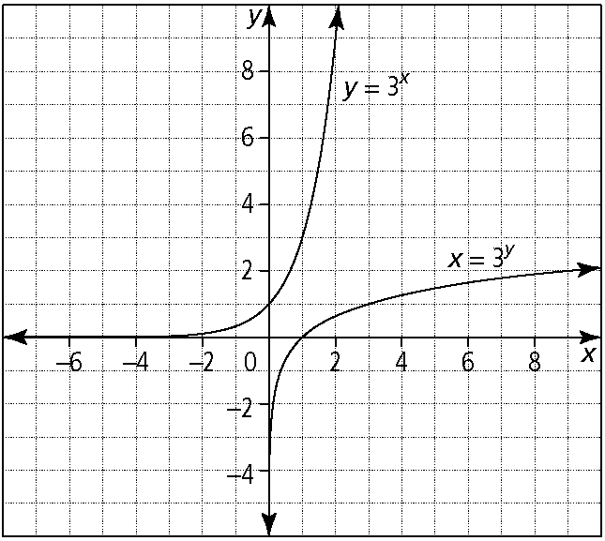

**c)** Example: They are reflections of each other over the line *y*  *x*. Each point on the graph of one function (*x*, *y*) appears as the point (*y*, *x*) on the other graph. **6. a)** 

|  |  |
| --- | --- |
| **6b)** | **c)** domain: {*x*  *x*  0, *x* ∈ R}; range: { *y*  *y* ∈ R}; *x*-intercept: (1, 0); *y*-intercept: none  **d)** vertical asymptote at *x* = 0 |

**7. a)** domain: {*x*  *x*  0, *x* ∈ R}; range: { *y*  *y* ∈ R};  
*x*-int: (1, 0); *y*-intercept: none; vertical asymptote at *x* = 0

**b)** domain: {*x*  *x*  0, *x* ∈ R}; range: { *y*  *y* ∈ R};  
*x*-int: (1, 0); *y*-intercept: none; vertical asymptote at *x* = 0

**8. a)** 5.9 **b)** 3.1 **c)** 2.7 **d)** 1.5

**9. a)** (4, 0) **b)** no *y*-intercept **10.** *k*  6

**Section 4.2**

**1. a)** translation hor. 8 units left and vertically 1 unit down

**b)** refl. in the *y*-axis, compressed horizontally by a factor of 

**c)** refl. in the *x*-axis, stretch vertically by a factor of , translation horizontally 10 units right and vertically 9 units up

|  |  |
| --- | --- |
| **2a)** | **3a)** |
|  |  |
|  |  |

**b)**  **b)** *y*  log6 *x*  2

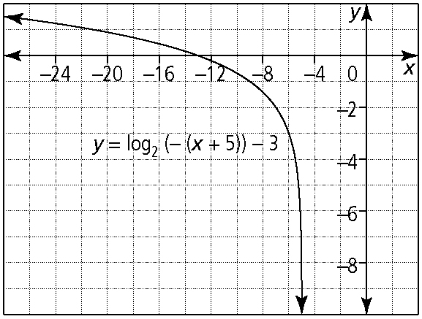

**4a. b.**

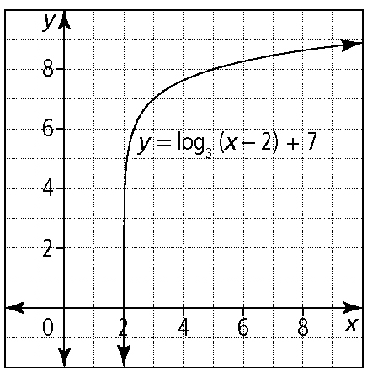

|  |  |
| --- | --- |
| **c)** | **5. a)** equation of asymptote: *x*  0; domain: {*x*  *x*  0, *x*  R}; range: { *y*  *y*  R}; *y*-intercept: none; *x*-intercept: (, 0) |

**b)** equation of asymptote: *x*  4; domain: {*x*  *x*  4, *x*  R}; range: { *y*  *y*  R}; *y*-intercept: none; *x*-intercept: (4.5, 0)

**c)** equation of asymptote: *x*  2; domain: {*x*  *x*  2, *x*  R}; range: { *y*  *y*  R}; *y*-intercept: (0, 2.4); *x*-intercept: (1.4, 0)

**d)** equation of asymptote: *x*  10; domain: {*x*  *x*  10, *x*  R}; range:{ *y*  *y*  R}; *y*-intercept: none; *x*-intercept: (12, 0)

**6. a)** or *y* = log4 *x* − 1 **b)** *y*  3 log2 *x*

**c)** *y*  log3 (2*x*) **d)** *y* = −4 log4 *x*

**7. a)** a vertical stretch about the *x*-axis by a factor of 2, a horizontal stretch about the *y*-axis by a factor of , a refl. in the *x*-axis, and a translation 4 units right and 7 units up

**b)** a vertical stretch about the *x*-axis by a factor of 0.2, a refl. in the *y*-axis, and a translation 1 unit left and 3 units down

**8. a)** *a*  1; *b*  1; *h*  5; *k*  2; *y*  log2 ((*x*  5))  2

**b)** ; *b*  0.25; *h*  0; *k*  0; 

**c)** ; *b*  3; *h*  7; *k*  2; 

**9. a)** a vertical stretch about the *x*-axis by a factor  
of 5, a horizontal stretch about the *y*-axis by a factor of , a reflection in the *y*-axis, and translation 5 units right and 7 units down

**b)** a vertical stretch about the *x*-axis by a factor of 0.25, a reflection in the *y*-axis, and translation 2 units right and 5 units up

**c)** a vertical stretch about the *x*-axis by a factor of  and translation 1 unit left and 7 units up

**10. a)** *y*  log4 (*x*  10) **b)** *y* ≈ 19.02 log3 *x*

**Section 4.3**

**1. a)**  **b)** 

**c)**  **d)** 

**2. a)** log8 512  3 **b)** log2 8  3 **c)** log5 52.5  2.5 **d)** log 1  0

**3. a)**  **b)**  **c)**  **d)** 

**4. a)** 23 **b)** 11 **c)** 7 **d)** −14 **5. a)** 25 **b)** 16 **6. a)** 4*k* **b)** 1  *k* 6**c)** 2*k*  3 **d)** 0.25*k*  2 **7. a)** *x* ≠ 0 **b)** *x* ≠ 0

**8.** 7.6 **9.** 100 000 times more **10.** 8.1

**Section 4.4**

**1. a)** no solution **b)**  **c)** 3 **2. a)** 8 **b)** 2 **c)** −3

**3. a)** 1.79 **b)** 1.01 **c)** 13.6 **4. a**) −1.76 **b)** −1.81 **c)** −9.32

**5.** Example: If Nicole's work is preferred it is because it uses the definition of logarithm to convert 5 into log2 32. Once this is done, the logarithm can be dropped from both sides of the equation. If Joseph's work is preferred, it is because it converts the logarithmic equation into an exponential function.

**6.** Example: Samuel’s error occurs in his first calculation: log 500 divided by log 5 does not equal log 100. To solve the equation correctly, Samuel should first calculate the log of 500 and then divide this value by the log of 5.



**7. a**) 2.59 **b)** 8 **c)** no solution **d)** 6 **8. a)** 23.4 compounding periods, so 11.7 years **b)** 63.3 compounding periods, so 31.7 years **9.** *b* ≈ 4.29 **10.** 1.94 m