Senior CAD Urban Planning Project 3

Urban planning is the design and layout of areas of the city. This would include:

residential subdivisions;
industrial, commercial and retail spaces;
parks and green spaces;
roads, sidewalks, traffic flow, and public transit,

Many areas of our city (and many others) are being made more appealing and natural.
Cook Street Village and Quadra St are two examples and this revitalization.

One local area which may be in need of this process is the area of Cordova Bay Rd. just north of McMorrans Restaurant. This area includes a current strip mall, large parking area (some unpaved, and possibly a corner lot across the side street (an old gas station).

Your Project will require you to update this area to be more appealing.
You will need to consider the following

- Draw a new mall (which must include the services already present: bank, food store, post office, restaurant, and small retail stores). Also consider rear deliveries and building utilities.
- A new parking lot with trees, easy parking, courtyard, and lighting. There will be some underground parking. You can decide who uses this (tenants, customers, and both)
- 40 condo units. These can be on top of the retail space or in their own building.
- This is a major project you will need to include road work including curbs, centre planters, street lights, and a traffic light to control traffic into and out of the mall
- You may use the old gas station across from the mall as part of your plan

You will need to research sizes of parking spaces, sidewalks, and roads.

Here are a couple of links about the proposed new mall:

https://www.timescolonist.com/news/local/developer-offers-vision-of-new-village-centre-at-cordova-bay-plaza-1.2341022

https://victoria.citified.ca/news/5229-mixed-use-residential-and-retail-complex-pitched-for-cordova-bay-gas-station-property/

Part 1) Initial Planning

Read the entire assignment and watch the Uptown video.

Look at the considerations below to help you with this initial plan.

Draw the property outline to help you with space.

Think about how much space things are going to take.

For example:

A small condo might be 10m x 10m and you need 40 of them.
Let's say we want 10 condos per floor - 5 on one side of the 2m wide hall of 5 on the other side
Each floor will will then be 22m x 50m and we’ll need 4 floors of condos

50m long - 5 condos x 10 m each
22m wide - 2 condos of 10m each + a 2m
hallway
Times 4 floors

We don’t need to draw the inside but you do need to figure out approximately how much space you will need for the building.

Now where are you going to put it on the property? Can all the condos get some sort of an ocean view? What about property owners behind the mall that may lose their ocean view?

You will need to do something like this for stores, parking etc. This can be done in your head but you need to show some sort of thought process in your design.

This doesn’t need to be to scale but should be a top(plan) view and show general locations of buildings and parking ideas.

The important part of this project is the thought process and problem solving. Here are some things to consider:

Why did you put the condos where you plan to put them?

How high are they? Is this going to be a problem?
Can you maximize ocean views?
Are they in a separate building or above the mall?
Do residences have separate parking? maybe underground?

Have you considered parking? How many spots for customers are needed?

Have you considered traffic patterns (both vehicle and pedestrian)?
How are cars getting into the property? (vehicle entrance(s))
Do you need traffic lights at the intersection or elsewhere?
How about deliveries to the stores? Should there be an entrance at the back of the stores for trucks to unload?

Have you designed pedestrian and meeting spaces such as tables and trees and planters?

Uptown is a great example of these design criteria. Make sure you watch the uptown video.
Does the roof extend over sidewalks in front of the shops to provide rain and sun protection?

Have you researched and taken into account the community concerns about the project?

See the links in the assignment plus look for any other info about the area.

Do a PAPER SKETCH 1st!! Take a pic of your sketch and send it to me through Google Classroom.

Here are some examples of professional sketches:
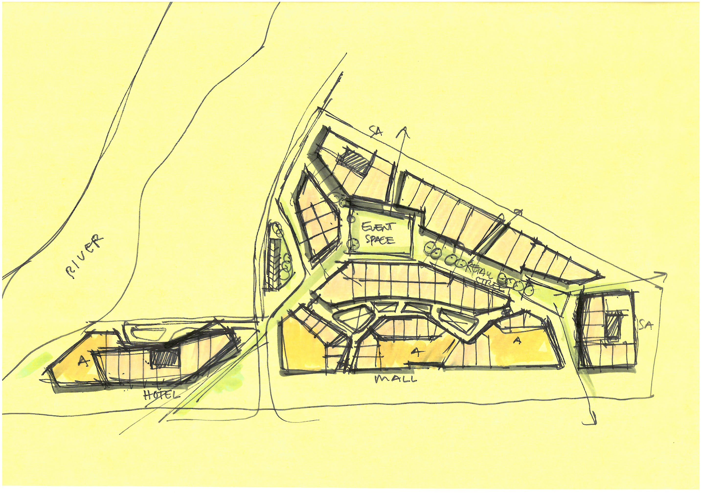

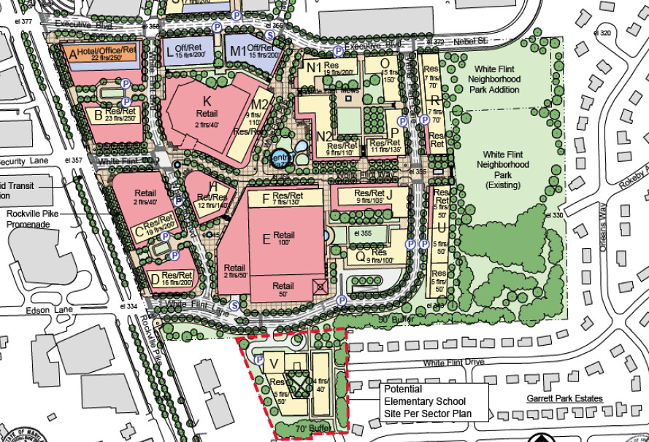

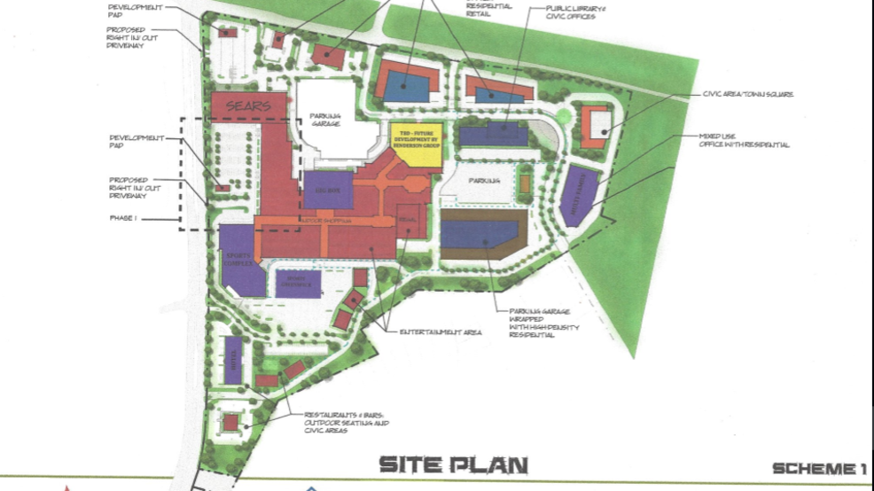

Part 2) Getting started in Digital Format

Make sure you’ve watched the video in the unit folder. This is a local mall (Uptown) and is a professional rendering in movie format of a mall design. This is a walkthrough of the new Uptown mall before it was built. You will not need to go into quite as much detail but you can add people and cars.

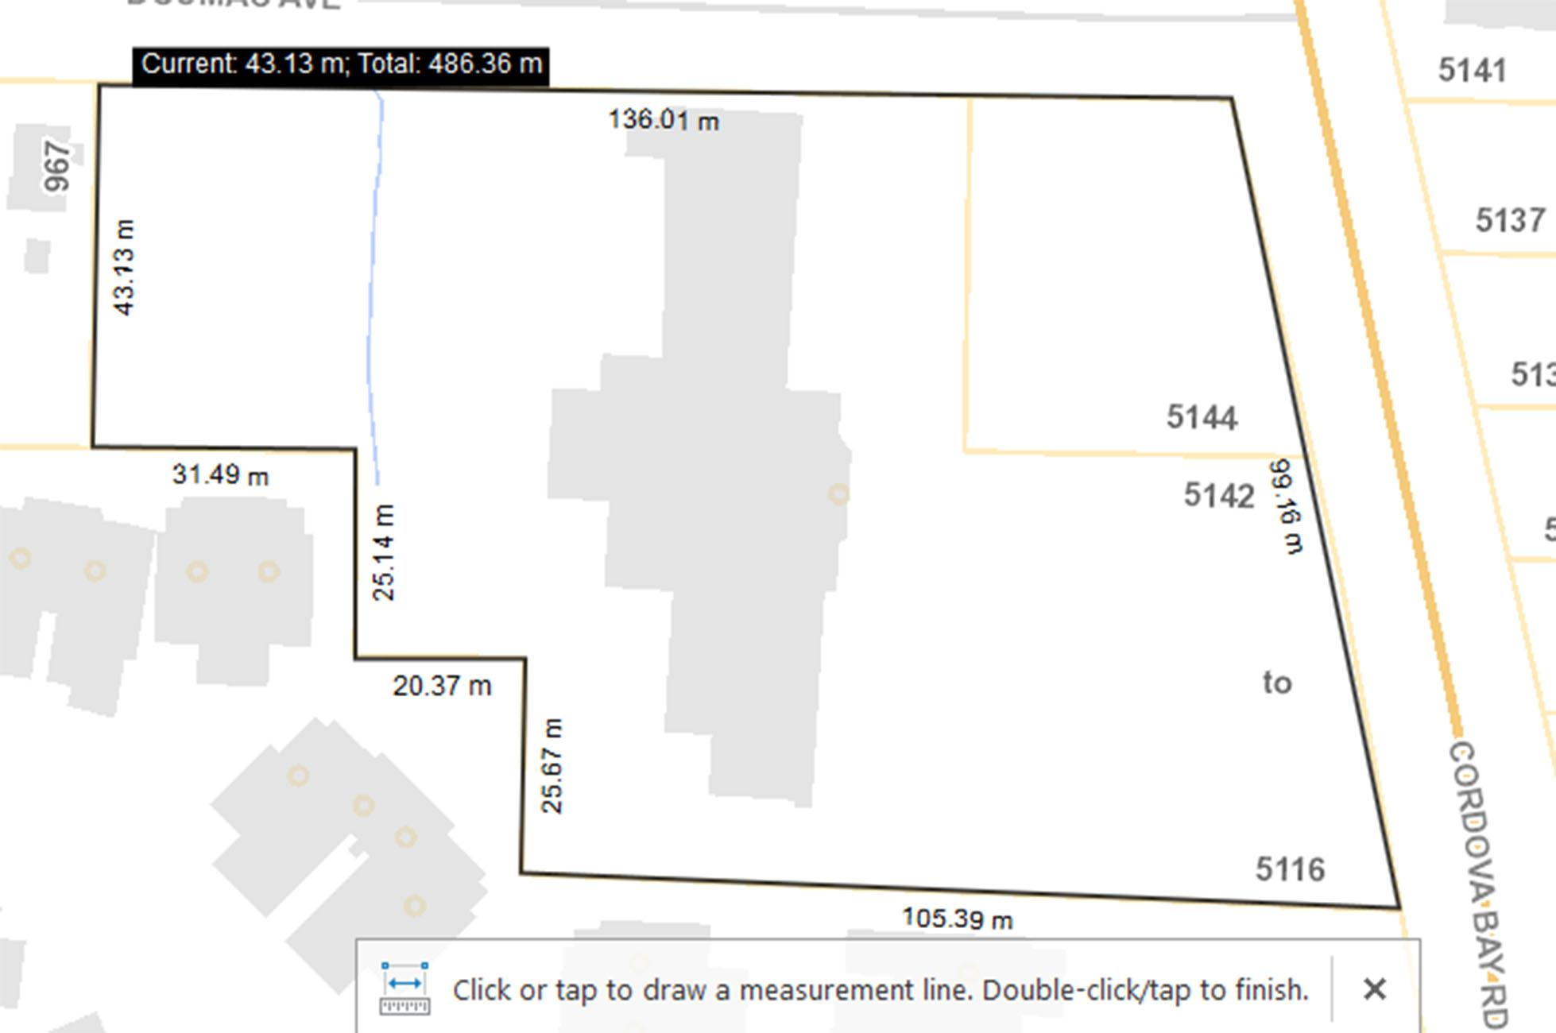

This is how the site looked for decades. You can see the gray building above showing the mall how it used to stand. (It is site is currently a big hole in the ground)

Using Vectorworks, set up your layers, titleblock, and border.

- Draw the shape of the property into Vectorworks. Assume all corners are 90 degrees except the two on the right at Cordova Bay Rd.
- Draw your building(s) with height in the proper location and start getting in parking spots. This is not set in stone! you will need to change positions and sizes as you go along in Part 3.
- Add parking spaces from the Resource Browser
- Determined where the entrance driveways would be located and put them in place
- Add the entrance ramp for the underground parking
- Place objects such as tables and chairs in your designated sitting area(s).

2-3 hours work
Part 3) Adding more

- Design your underground parking
  - Add support pillars every 5 parking spaces to hold up the building above
  - Add parking spaces based of the number of spots you think you need
- Determine the sizes for the stores. A grocery store needs a lot of space whereas a bank or post office needs much less.
  - Decide on how you’re going to place these stores in the space you allotted in part 2.
  - Maybe smaller stores are separated by an open walkway in the middle?
  - Draw all the outside walls of all your stores on your drawing with labels
- Put a screenshot of your image of your design to this point on this sheet.

This should be about 2-3 hours work

Send me a screenshot of your image.

Part 4) 3D Buildings

This week you will make buildings 3D.

This will be an external plan of the mall and road area. You do NOT need to worry about the inside of the buildings.

For your buildings show the following:

- Exterior doors and windows for all buildings
- Roof and any overhangs coverage sidewalk areas (if your design includes these)
- All textures for surfaces.
- Make sure you have provided balconies for each condo unit.

2-3 hours work

