Assignment 3: Compound curves and Organic shapes

So far your assignments in sketchup have used geometric shapes to make other shapes. However, since many of the objects we design are made to be used by human beings we need to shape the objects to fit our hands, backs, feet, etc.

Think about computer mice, desk and car chairs, and cooking utensils all need to fit the human body.

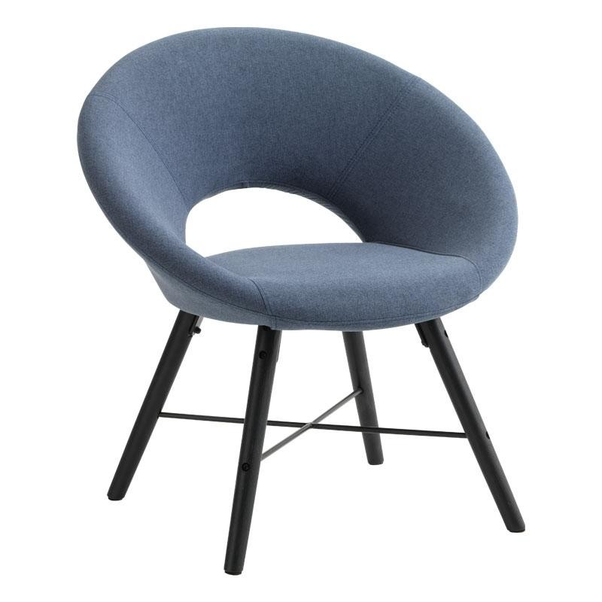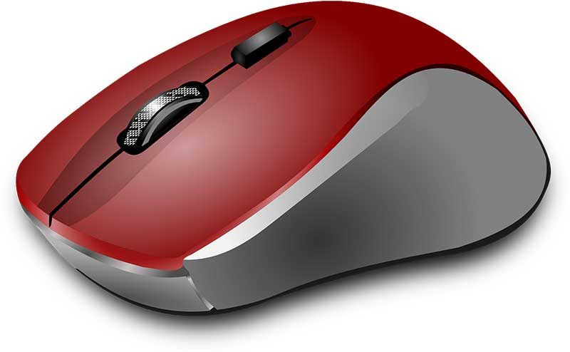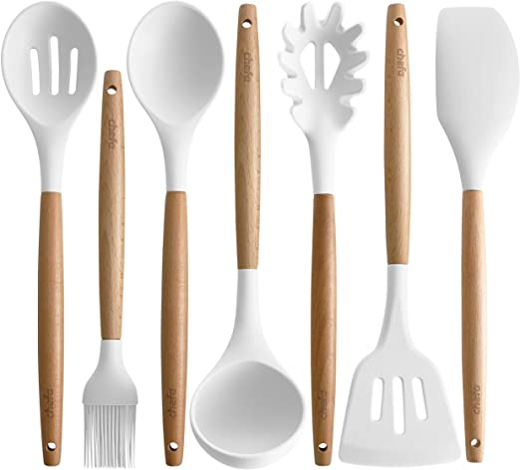

Car, boat, and airplane bodies are designed to reduce wind or water drag and require complex shapes.

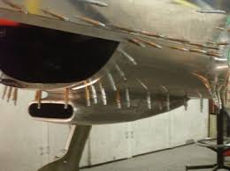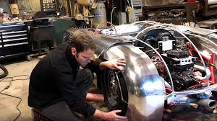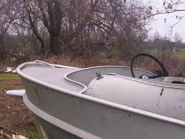

We also see complex shapes in architecture.

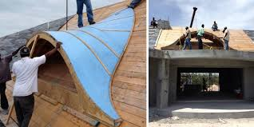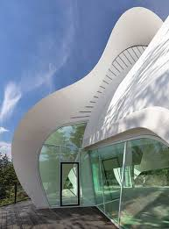

Making organic shapes with complex curves (curves going in more than 1 plane) can be difficult. We are going to take an orthographic drawing (top, front, side) of a motorcycle gas tank and turn it into a 3D gas tank with a compound shape. This takes a bit of time and patience. Watch the youtube link below to get an idea of what we’re going to do.

https://www.youtube.com/watch?v=bOEb3wRgwdA

The video doesn’t start at the orthographic drawing so I have included in the assignment much more professional videos to show you how to import the orthographic drawing, trace the shapes, and orient the images into a 3D pattern.

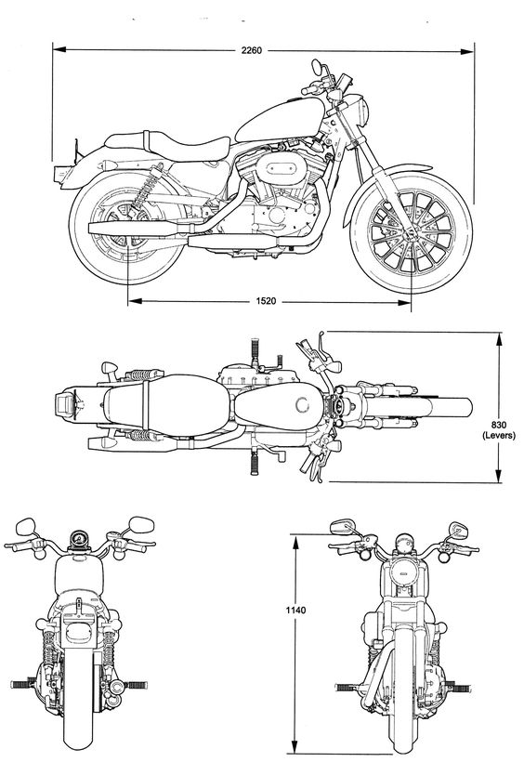 to 