AUTOCAD 2D Lessons

AutoCAD offers several different versions such as Architechure, Mechanical, and others.
You need to work in AutoCAD Mechanical 2017 for All your 2D and 3D lessons
Please make sure you've opened the correct version of AutoCAD
As you go through the following lessons you will see techniques you've seen before and some new ways of doing things that are different than Vectorworks.
2D First!
In these lessons will walk you through exercises with the aim of helping you learn how to draw in 2D using the software AutoCAD.
Lesson 1: Drawing lines
To begin, we will start by trying to draw this simple figure below. Too simple right? The objective here is to learn how to use the command window in AutoCAD in order to draw without using the mouse. This will help us have a first glimpse on how this window works.
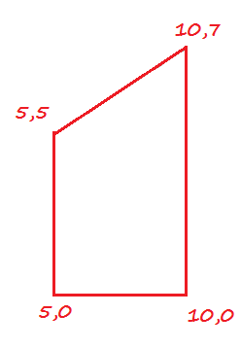

We have 4 points and we have the coordinate of each of them. So, basically we have each starting point of our lines and each ending point.
AutoCAD draws lines using coordinates. To better explain, we put our figure in a system of coordinates in the image below in order to improve our understanding. If we consider a coordinate system formed by X, Y, this is how our exercise will fit in the system.
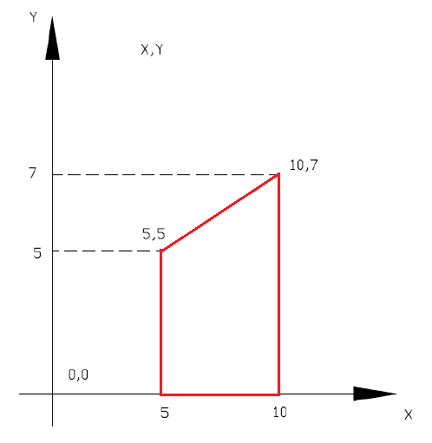
To draw this, open a new file in AutoCAD
- Turn off Dynamic Input (F12) or click icon at very bottom of screen
- Turn off Ortho (F8) or click icon at very bottom of screen
- Type “LINE”
- Specify first point: 5,0
- Specify next point or [Undo]: 10,0
- Specify next point or [Undo]: 10,7
- Specify next point or [Close/Undo]: 5,5
- Specify next point or [Close/Undo]: 5,0
- Hit the ENTER once more
- Click on TOP on View Wheel (top right of screen)
(The part in bold is what AutoCAD is asking you to enter. You will see those same words displayed in the command windows. You should enter are those coordinates, e.g. 5,0 -> 10,0 -> 10,7 and so on. However, remember after each step you need to validate your action by pressing the ENTER key on your keyboard)

There you go! We are done with creating the figure. You noticed how we are able to draw without using a mouse. It may be difficult for a newcomer but not impossible.
AutoCAD draws lines from one point to the other and starts the next line where the previous one ended. In step 7, we disabled the LINE command and at that step you can also press the ESC key instead of the ENTER key, it will serve the same purpose. Step 8 is just to zoom out completely so you may see what you have just drawn.
This command line is not seen in Vectorworks but can be very useful when drawing. Keep this in mind as you work!
Another way to draw lines:

We'll start by drawing a basic figure. Our figure has 6 points: A, B, C, D, E and F, and we know the distance of each segment as AB=5, BC= 7, DC= 2.5, DE= 3, EF= 2.5, FA=4.
The coordinate of the starting point is given but is not that important for this exercise.
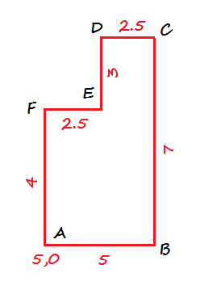
To draw this figure.
- Turn on Ortho (F8)
- Click mouse
- Specify first point: 5,0
- Give a right orientation to your line using your mouse, and type 5
- Orientate your line upward using your mouse and type 7
- Give the left direction to your line using your mouse and type 2.5
- Orientate your line downward and type 3
- Give the left direction to your line and type 2.5
- Orientate your line downward and type 4
- Press ESC or space bar
Now try the exercise below:


