Lesson 4: Fillet

Now you will draw a rectangle with rounded corners and 9 circles, all in a way to replicate the figure below.
Today, we will learn how to use the FILLET command.
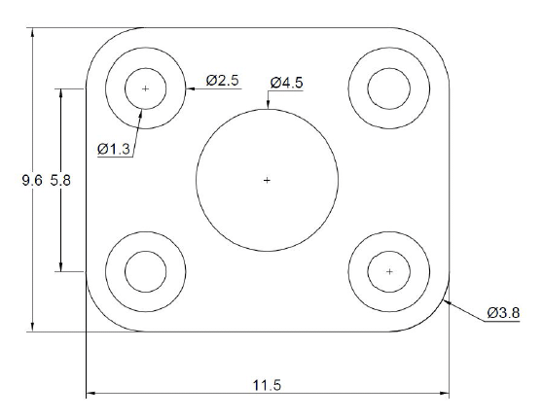
Step A
Draw a rectangle of width 11.5 and height 9.6.

Step B
Give the corners of the rectangle the right shape using the FILLET command.
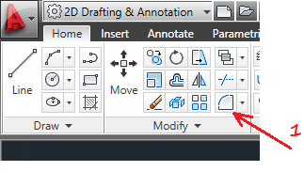
1 – Click on FILLET icon
2 – You should be able to read this in the command window:
Current settings: Mode = TRIM, Radius = 0.0000
3 – Select first object or [Undo/Polyline/Radius/Trim/Multiple]: r
4 – Specify fillet radius <0.0000>: 1.9
5 – Select first object or [Undo/Polyline/Radius/Trim/Multiple]: Select the first line
6 – Select the second line
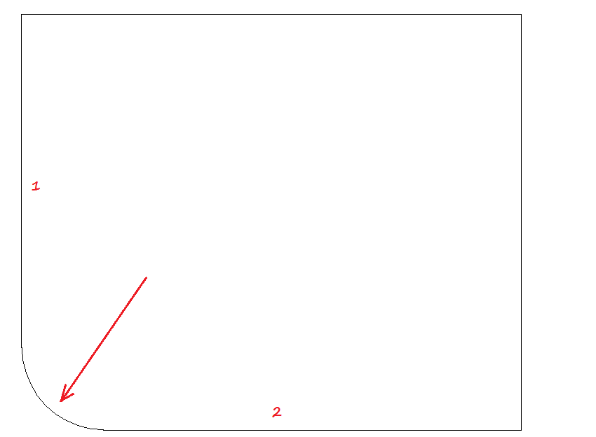
If you started from the corner indicated on the image above, the 2 lines you must have selected would be line 1 and 2. Do the same thing for other corners but you will now omit steps 2, 3 and 4. Click on the FILLET icon and select the lines. You should get this:
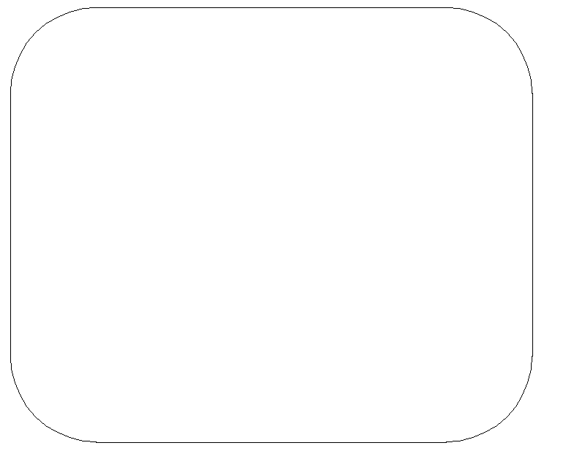
Step C
Click on the CIRCLE icon. The dropdown menu under the CIRCLE icon will allow you to select DIAMETER which will make this exercise easier
Since the centre of the circles is also teh centre of the fillet radius, we can bring the cursor over top of teh fillet and the centre mark will show up (see below). Click on the centre mark, then type in 1.3. Do all the 1.3 diameter circle 1st (you might see the advantage if you look at the diameter box. Then do the same for the 2.5 diameter circles.
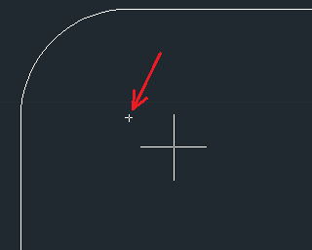
Therefore, you can easily find the center of your circle using this technique.
Step D
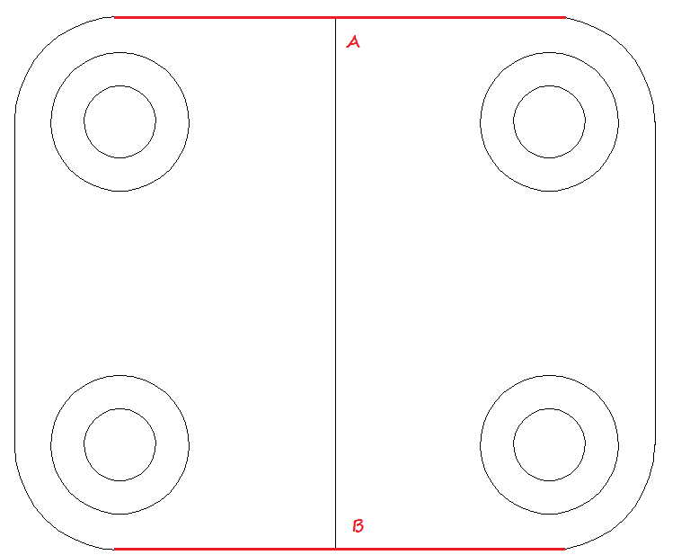
Hover over the Object Snap icon on the bottom tool bar, right mouse click and make sure Midpoint snap is turned on.
Draw a line from point A to point B. Point A is the center of its specific red line and the same applies for point B. Now, activate the CIRCLE command and draw the last circle from the center of the line we just drew from point A to B. Remember to delete this line at the end of this process.

