3D Lesson 5

We are getting a little more difficult in this AutoCAD 3D tutorial. Here is a good 3D AutoCAD exercise for beginners.
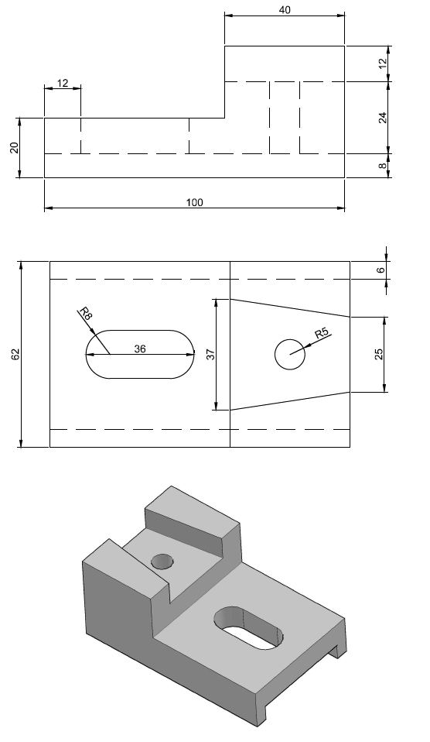

The first steps should be to draw 1, 2, 3, 4, 5 shown on the figure below. You can find dimensions on the figure above.
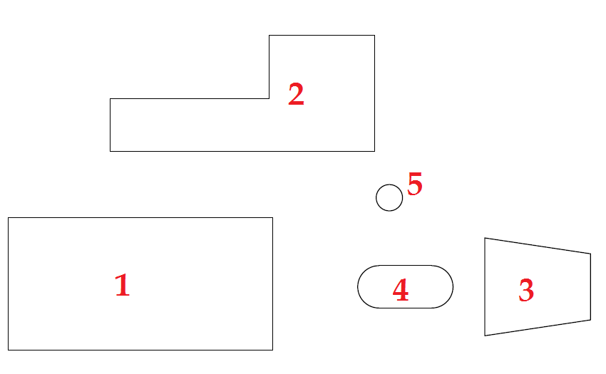
Use the REGION command on 1, 2 , 3 and 4. You will need to rotate 2 using the 3DROTATE command for it to be in a plan perpendicular to other objects.
See an example of the 3DROTATE command in teh file 3D 3DROTATE example.
If you do so, your project should look like this in an isometric view.
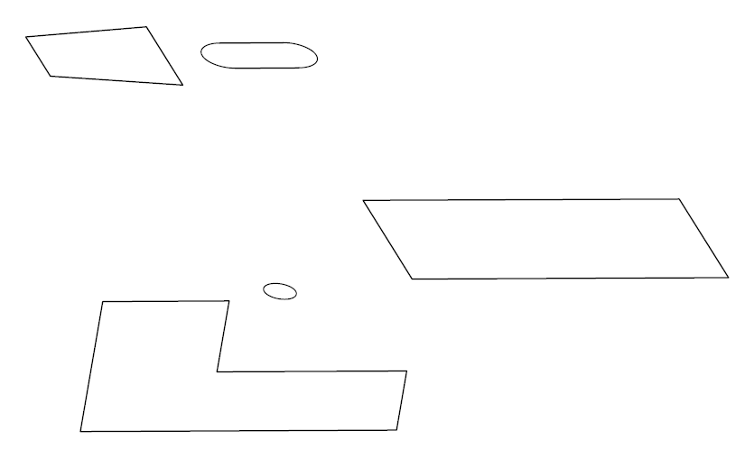
Now you need to use the EXTRUDE command to transform all these object into 3D objects. Extrusion length are given in the table below (you can also figure them out using the first image above)

Object | Extrusion length
1 | 8
2 | 62
3 | 12
4 | 20
5 | 44
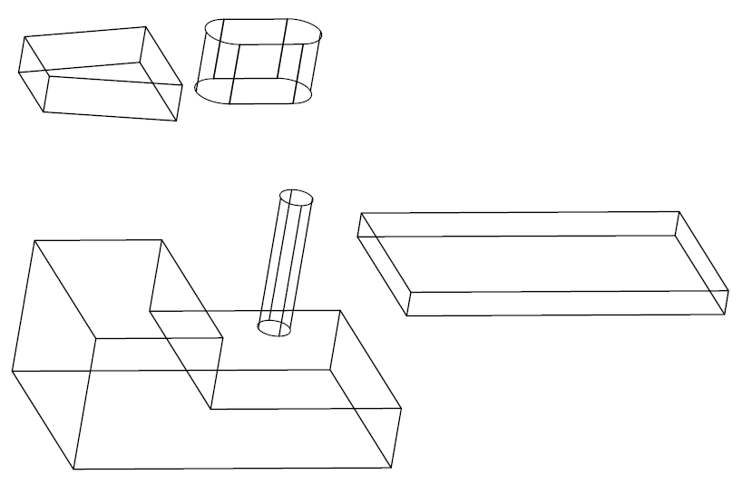
The most tricky part! You have to be able to place each object in such a way your project looks like the 3D figure below. This is a crucial part which will allow you subtract all the unneeded geometry from the principal object.
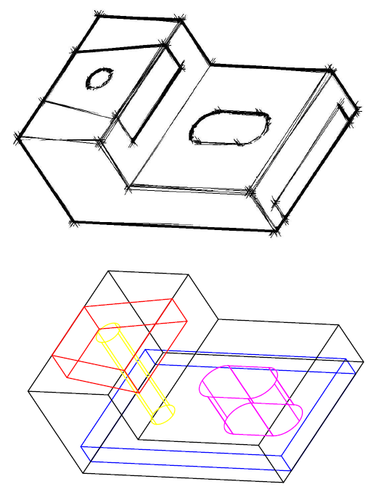
Final Step!
You need to subtract everything from 2 which is the principal object. Use the SUBTRACT command. And this will give you the result expected.

