Surface Modeling Tutorial

Introduction

In this tutorial, you will create a toy race car body design using AutoCAD
surface modeling techniques. The end result is shown in the illustration below.
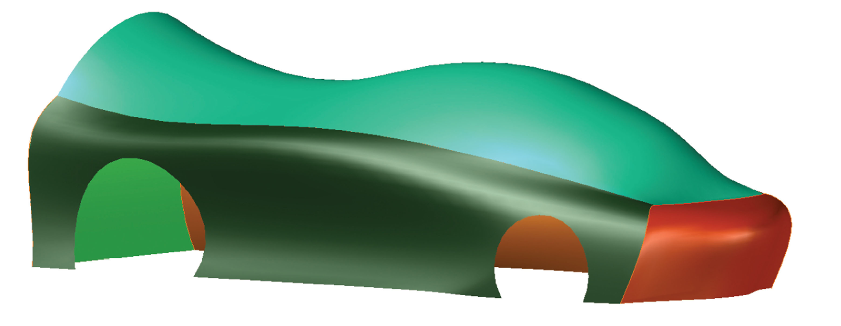

Creating the Sides

1. Open AutoCAD Mechanical.
Open the drawing Car_Body_Design.dwg available on the Claremont website (Beeston, Drafting, level 3, AutoCAD).

In the current view, the front of the car is to the right, the back is to the
left, the right side is nearest to you, and the left side is farthest from you.

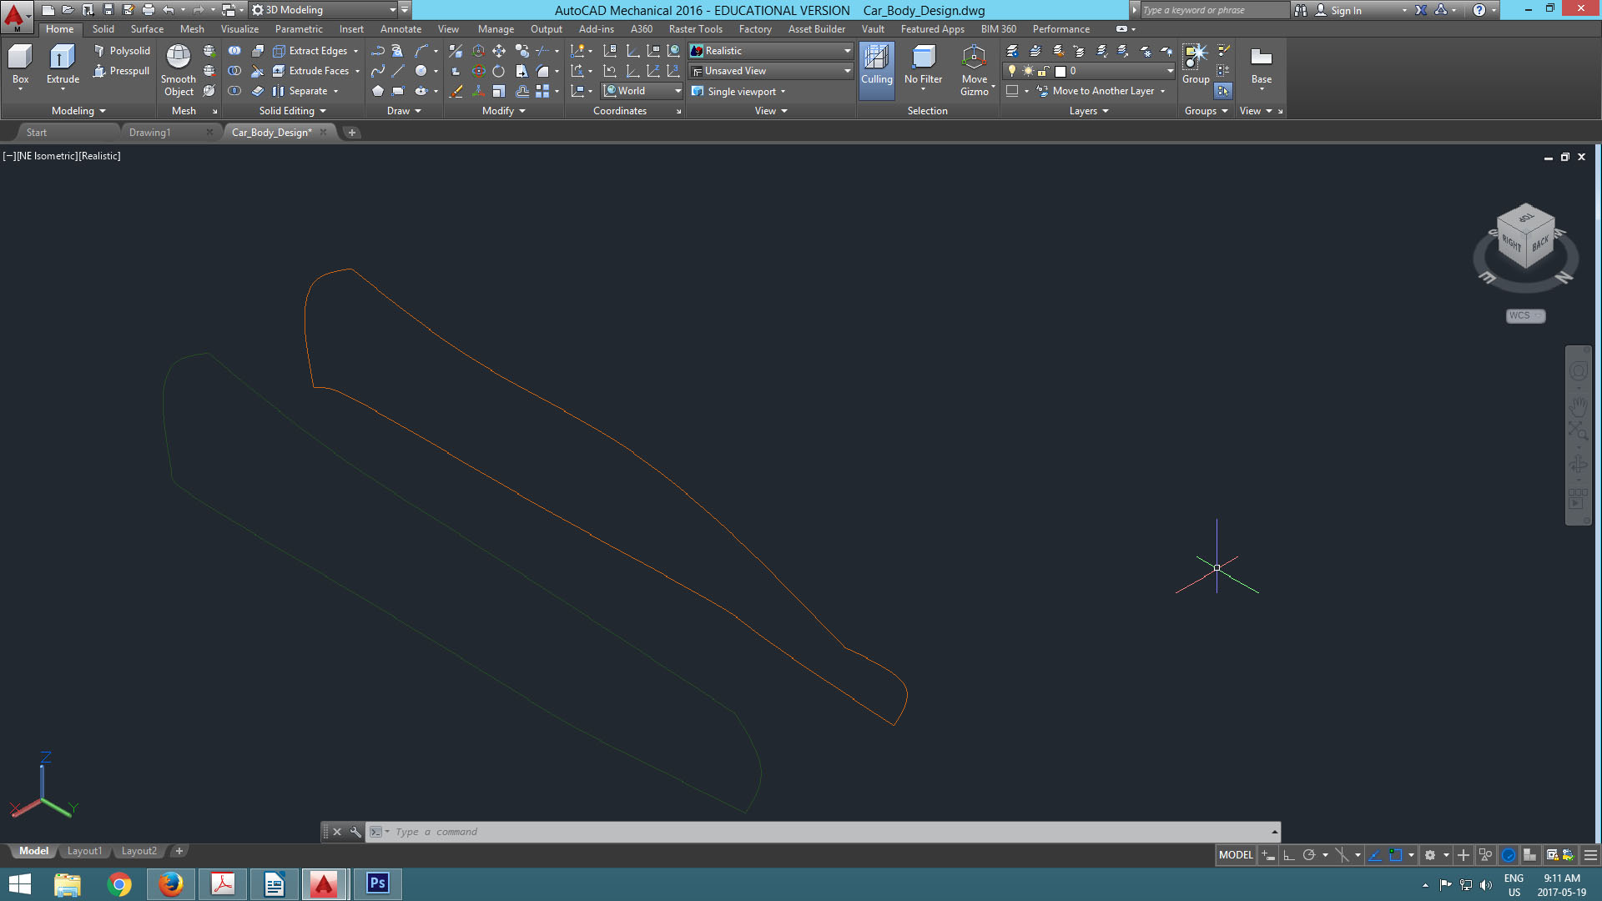

Setup up AutoCAD for your work:

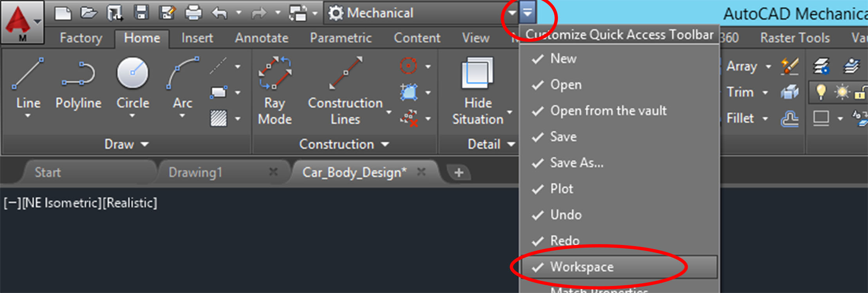
Click on the arrow above and check “workspace”

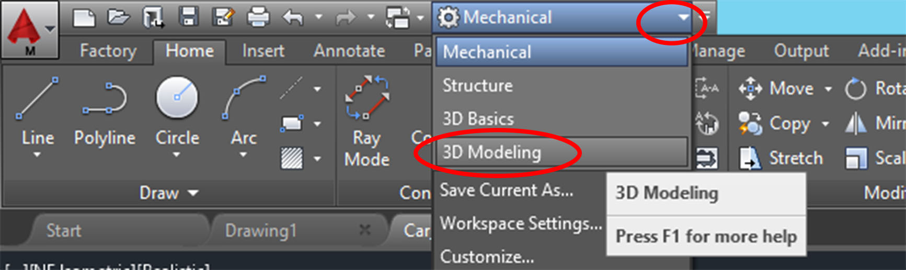
In drop box that appears select “3D Modeling”

2. Make sure the SURFACEMODELINGMODE system variable is set to 0 so that procedural surfaces are created. In addition, make sure the SURFACEASSOCIATIVITY system variable is set to 1 (on) so that associative surfaces are created. These settings can be verified in the Create panel on the Surface tab of the ribbon. The “Surface Associativity” button should be on (blue) and the “NURBS Creation” button should be off (white).

3. Set the visual style to Wireframe. You may need to type in “visualstyles” into the command box or look at the picture below for where to find the visual styles menu.

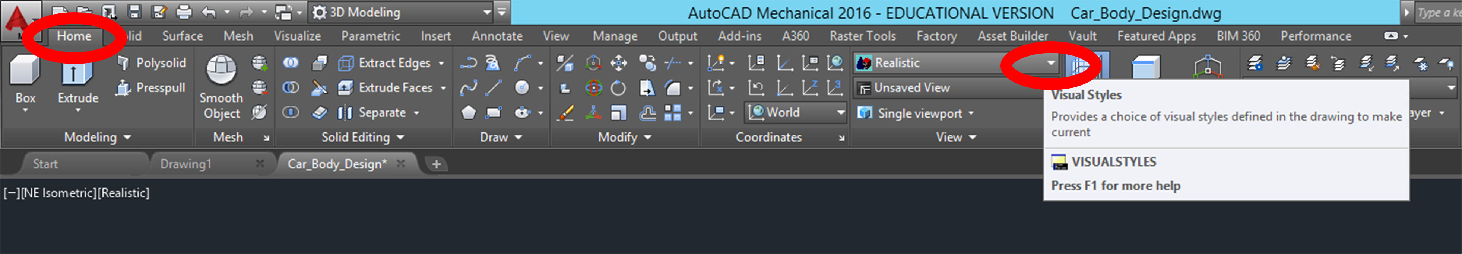

4. Set the Right_Side layer current. Freeze the Left_Side layer.

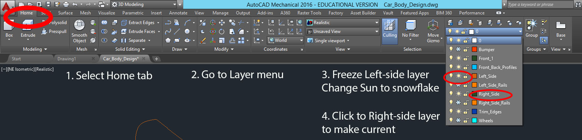

5. Pick the Loft button in the Create panel on the Surface tab of the ribbon to
initiate the LOFT command.

6. Select the long curves (top and bottom) as the cross sections and the short curves (front and back) as the guides for the loft. See the illustration below. This is tricky – keep trying! Select Loft, select cross section lines (one at a time), press Enter, right click, select Guides in the drop down menu, select the guide lines (one at a time), press Enter.

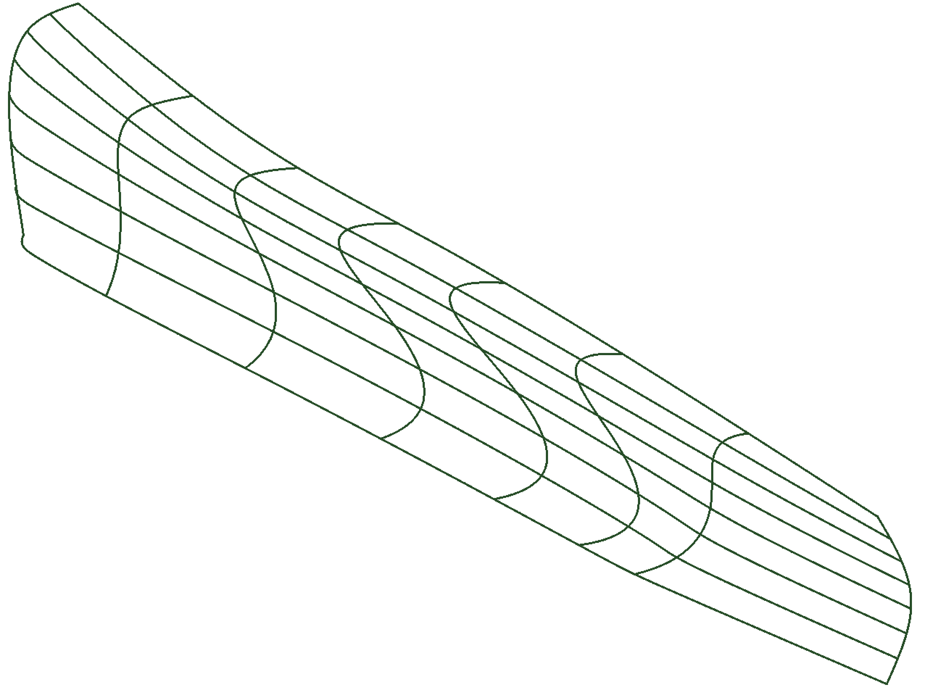
Guide
Cross Section
Cross Section
Guide

7. Thaw the Left_Side layer and set it current. Freeze the Right_Side layer.

8. Loft the left side of the car body. Select the long curves (top and bottom)
as the cross sections and the short curves (front and back) as the guides
for the loft. (Same as before)

Trimming the sides:

9. Thaw the Right_Side layer and set it current. Thaw the Right_Side_Rails
layer. Freeze the Left_Side layer.

10. Using the view cube, set the view to the Right orthographic view. See the
illustration below.

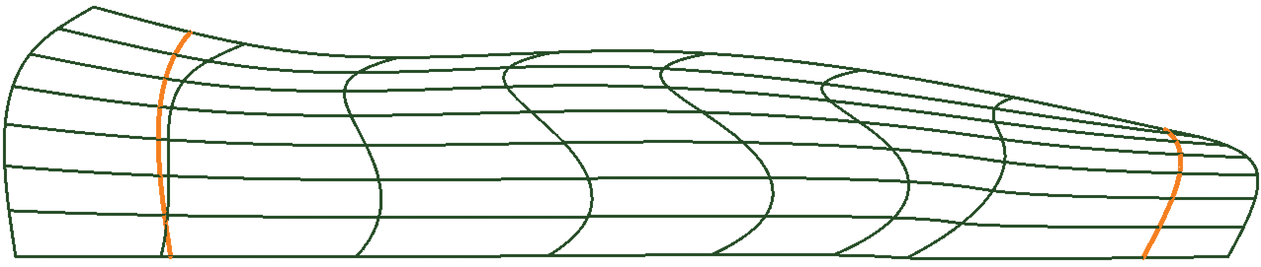
Curves for trimming

11. Pick the Trim button in the Edit panel on the Surface tab of the ribbon to
initiate the SURFTRIM command.

12. Select the right-side surface as the surface to trim. Then select the two curves as the cutting curves. Finally, select the areas to the right and leftof the cutting curves as the areas to remove. See the illustration below.

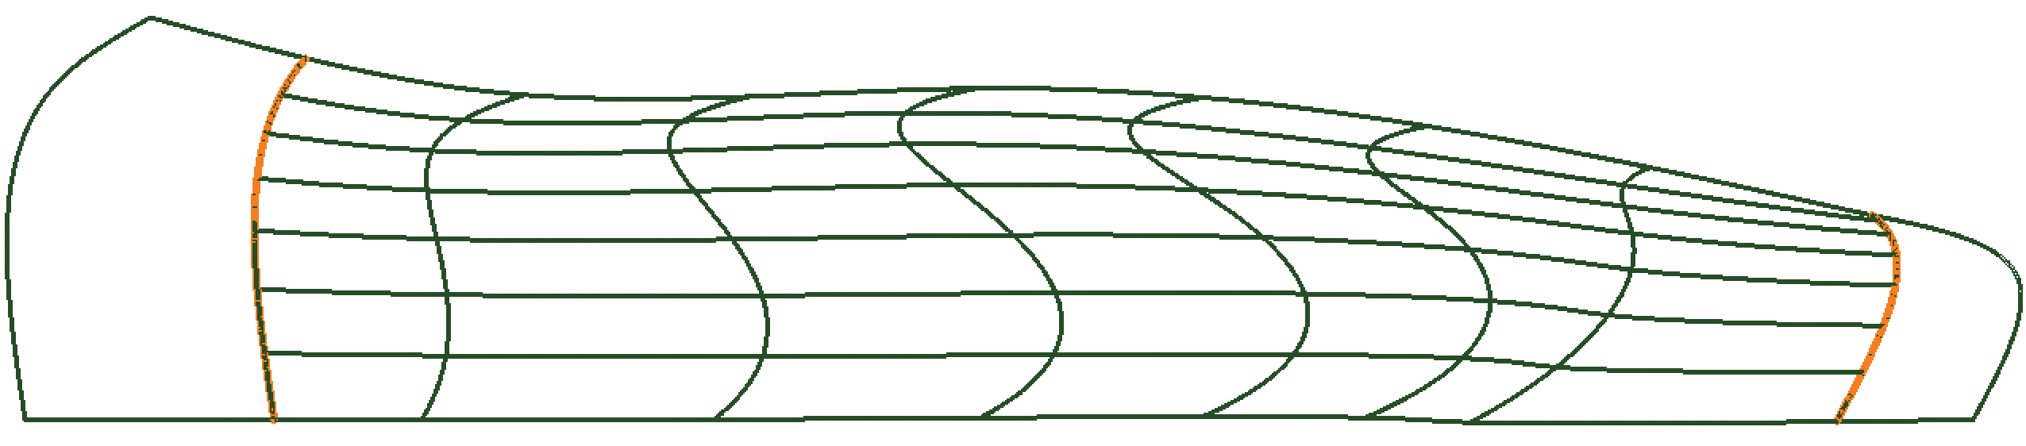
Areas removed

13. Thaw the Left_Side layer and set it current. Thaw the Left_Side_Rails layer.
Freeze the Right_Side and Right_Side_Rails layers.

14. Using the view cube, set the view to the Left orthographic view.

15. Pick the Trim button in the Edit panel on the Surface tab of the ribbon.

16. Trim the left side of the car body using the curves.

17. Thaw the Right_Side and Right_Side_Rails layers and use the view cube to
restore the home view. See the illustration below.

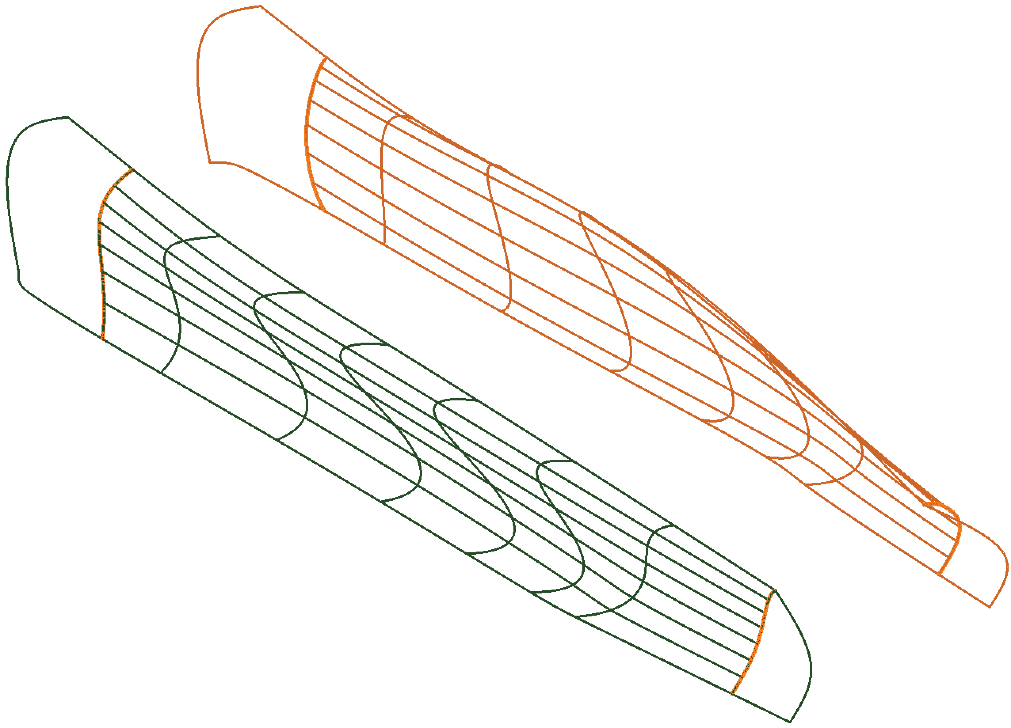
Creating the Front Bumper:

18. Thaw the Bumper layer and set it current. Freeze the Right_Side and Left_Side
layers. Leave the “rails” layers thawed.

19. Pick the Network button in the Create panel on the Surface tab of the ribbon
to initiate the SURFNETWORK command.

20. Refer to the illustration below. Select curves 1, 2, and 3 for the first direction
and press [Enter].

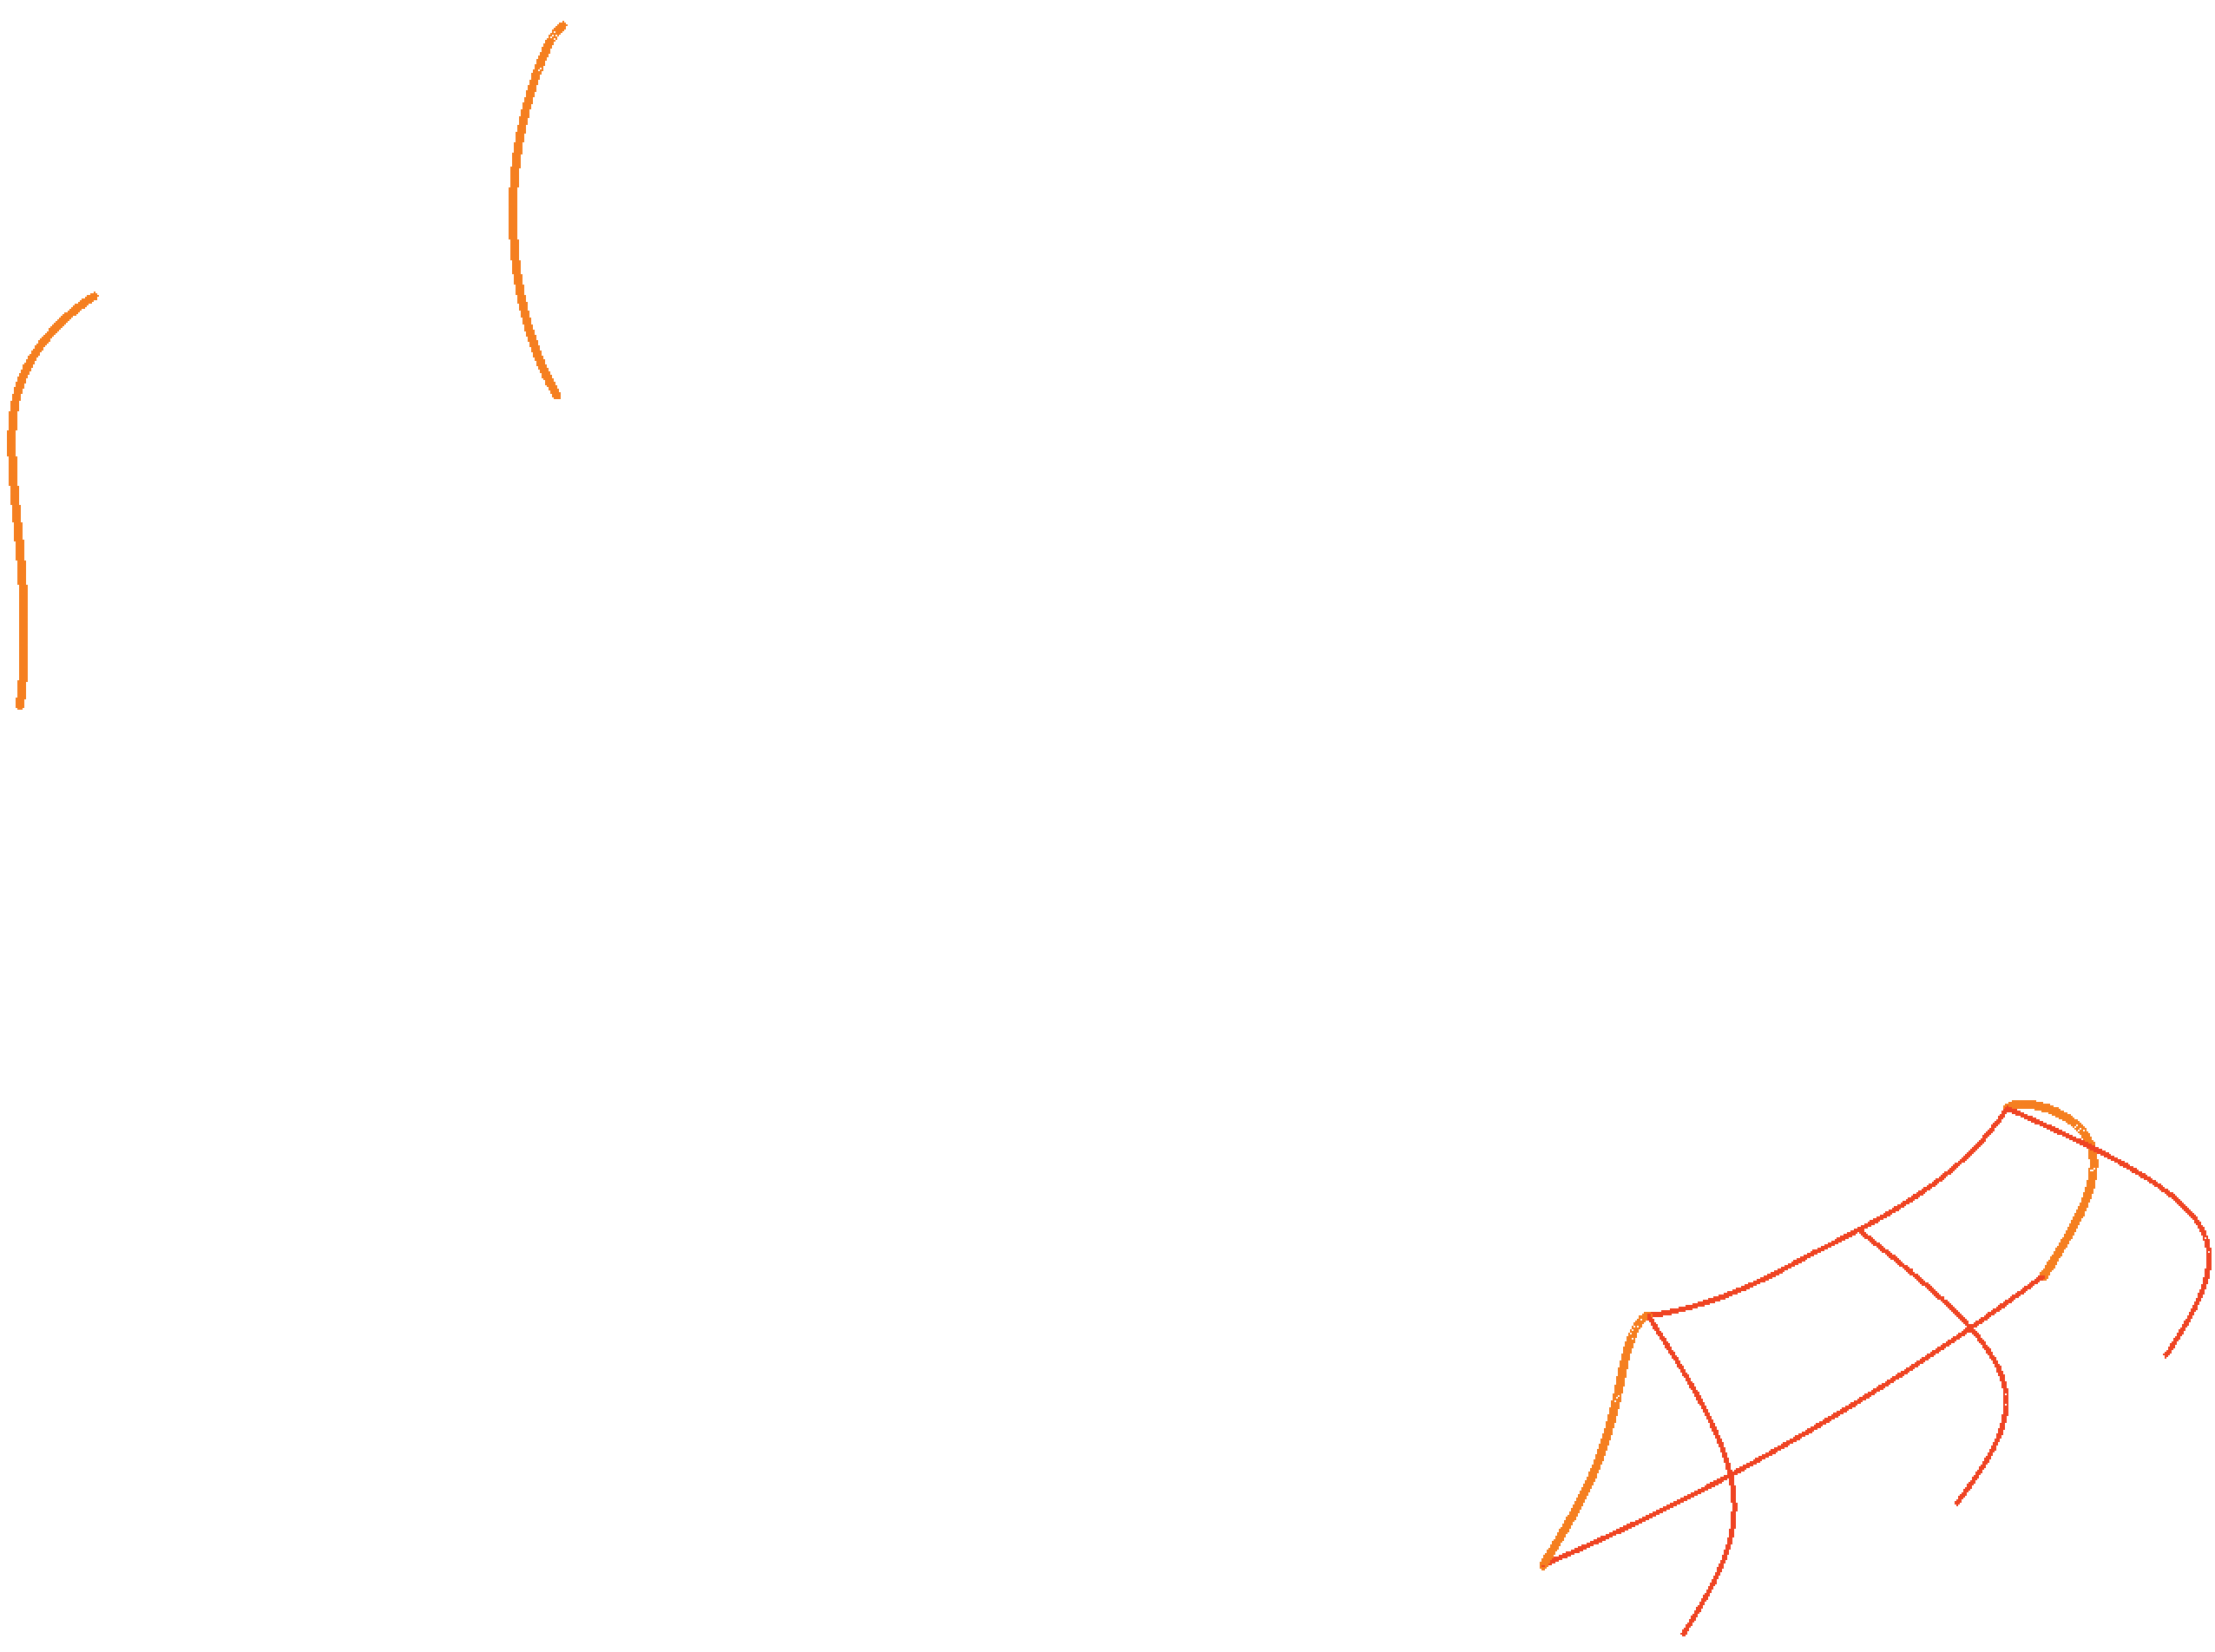
1
2
3
4
5

21. Select curves 4 and 5 as the second direction and press [Enter]. This is the front of the car.

22. Pick the Loft button in the Create panel on the Surface tab of the ribbon to initiate the LOFT command. Loft the two curves at the back of the car using cross sections only. See the illustration below.

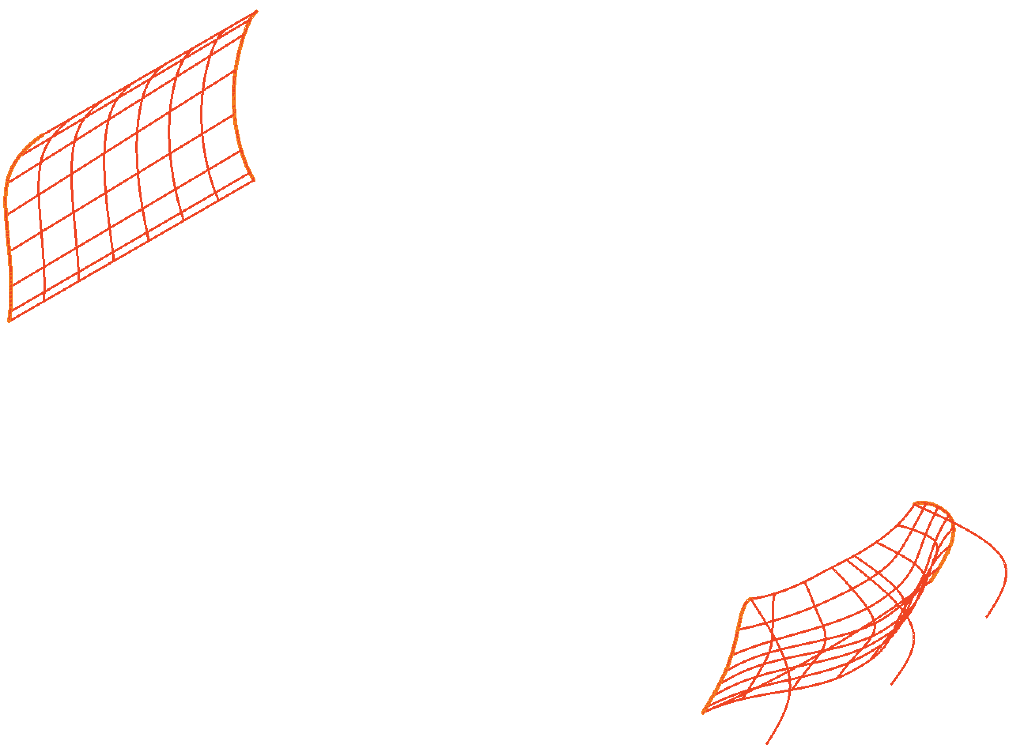
Car Rear
Car Front

Blending the Surfaces:

23. Thaw the Right_Side layer and set it current. Thaw the Left_Side layer.
Freeze the Right_Side_Rails and Left_Side Rails layers.

24. Create a new layer. Name the layer Top and set the color to ACI 120. Set
the Top layer current.

25. Pick the Blend button in the Create panel on the Surface tab of the ribbon
to initiate the SURFBLEND command.

26. Refer to the illustration below. For the first edge, select edge 1 and press
[Enter]. For the second edge, select edge 2 and press [Enter].
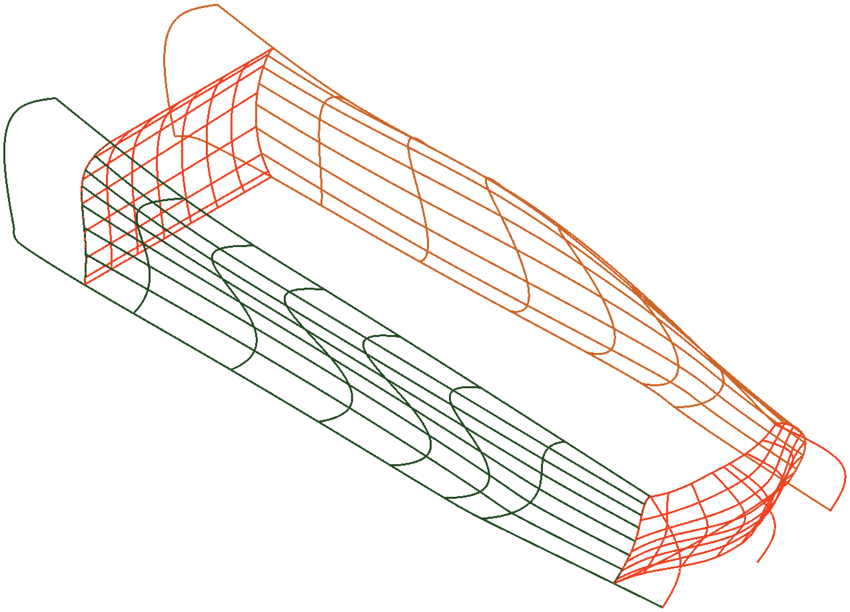
2
1
27. Using the Continuity and Bulge magnitude options, set the start and end
continuity to G1 and set the start and end bulge magnitude to 1.5.

28. Set the visual style to Shaded. See the illustration below. Needs to be patched.
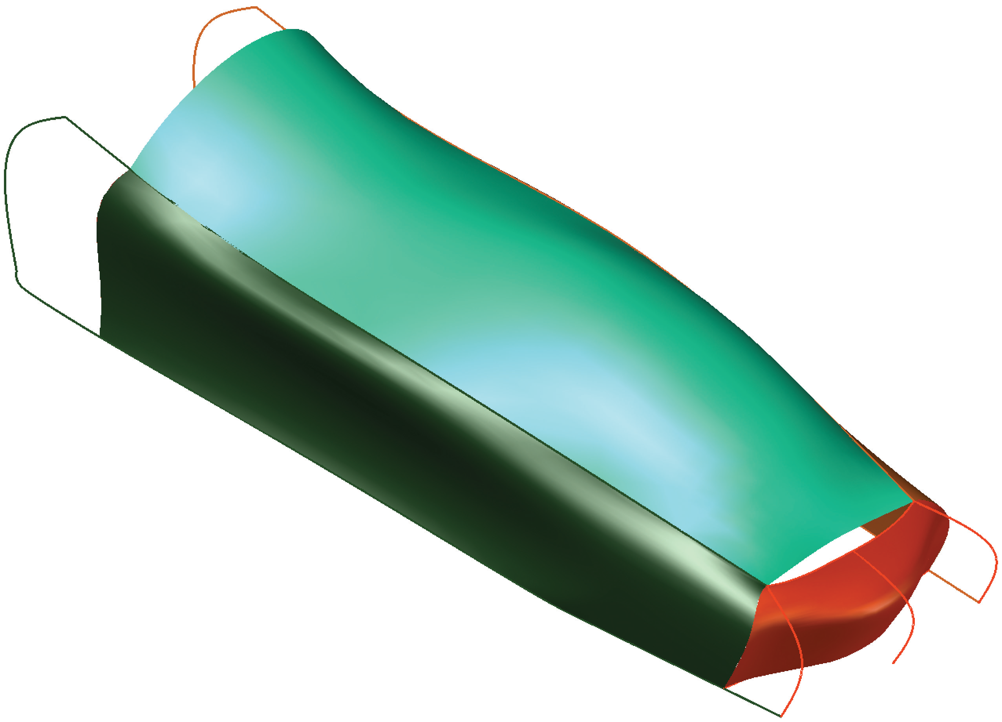
This area needs to be patched

Patching the Model:

You will need to patch the front and back of the car to close the body. The bottom of the car body will be left open for this design.

29. Zoom to the front of the car. Make sure the Top layer is set current.

30. Pick the Patch button in the Create panel on the Surface tab of the ribbon to initiate the SURFPATCH command.

31. Refer to the illustration below. Select surface edges 1 and 2 for the patch and press [Enter].

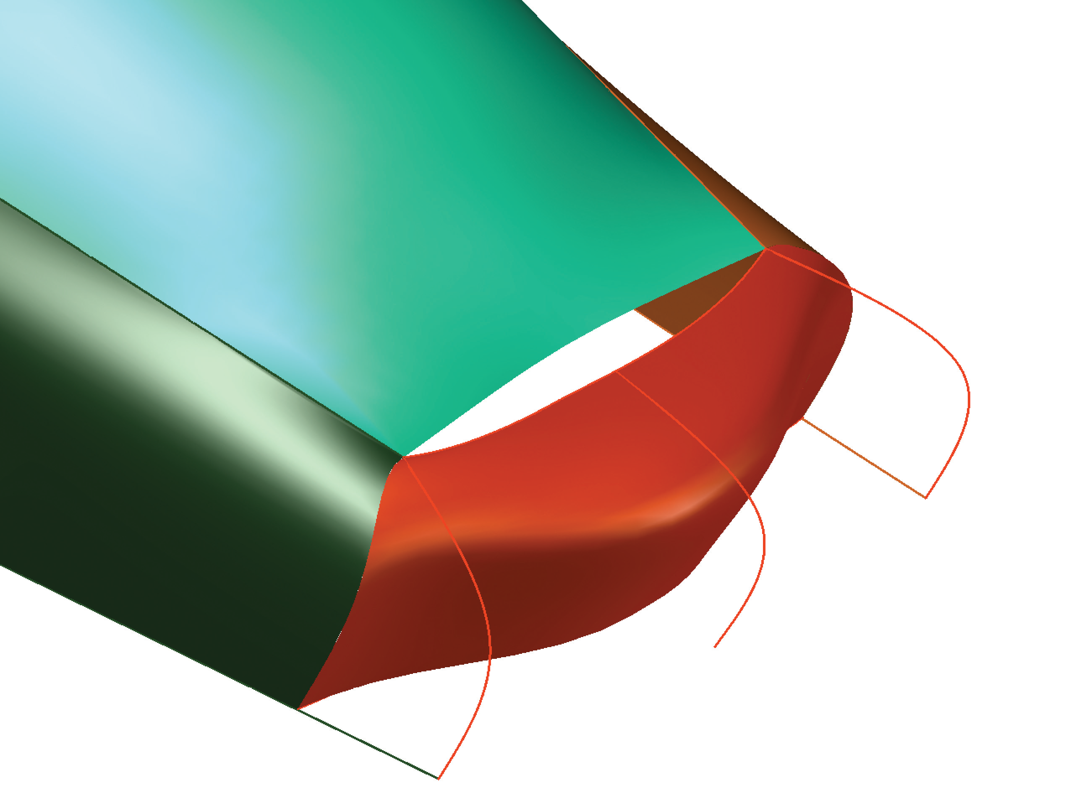
1
2

32. Using the Continuity and Bulge magnitude options, set the continuity to G1 and set the bulge magnitude to 0.2.

33. Rotate the view to see the back of the car.

34. Make sure the Top layer is set current.

35. Pick the Patch button in the Create panel on the Surface tab of the ribbon to initiate the SURFPATCH command.

36. Select the two surface edges to close the gap. Set the continuity to G2 and the bulge magnitude to 0.9. This creates a spoiler on the back of the car. See the illustration below.

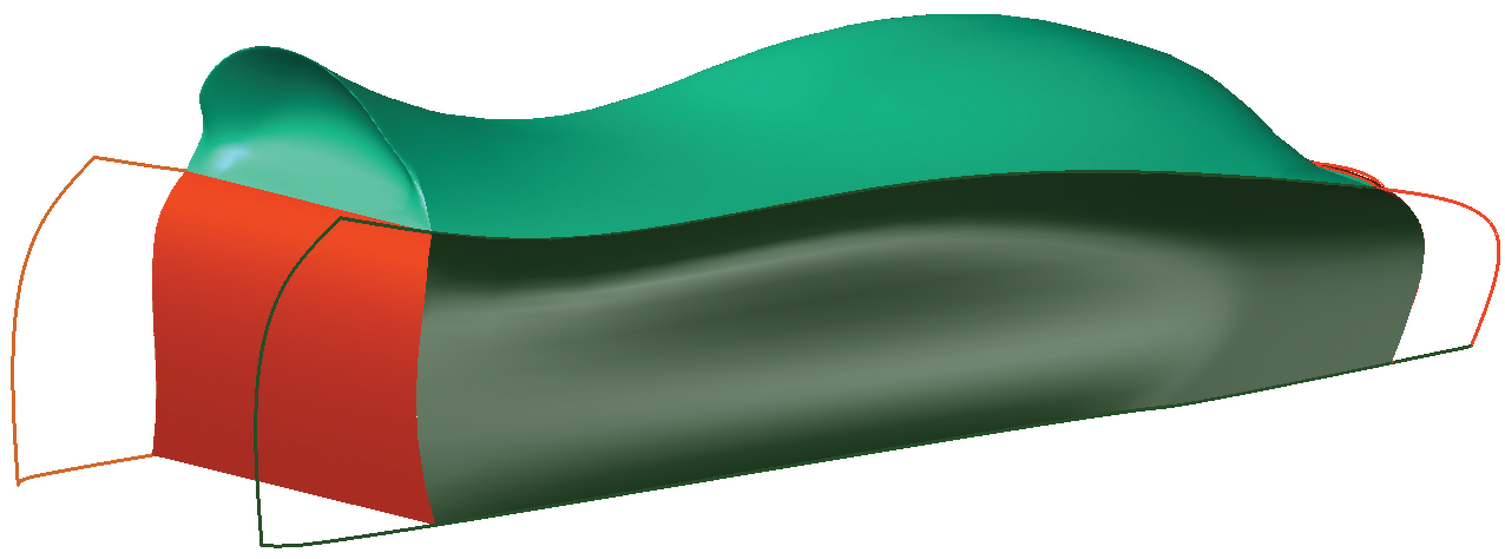
Patch creates a spoiler

37. Restore the home view. Also, thaw the Wheels layer and set it current.

38. Pick the Extrude button in the Create panel on the Surface tab of the ribbon to initiate the EXTRUDE command.

39. Select the two circles and extrude them three units so the extrusions pass through the body. These extrusions will act as trim edges to create the wheel wells. See the illustration below.

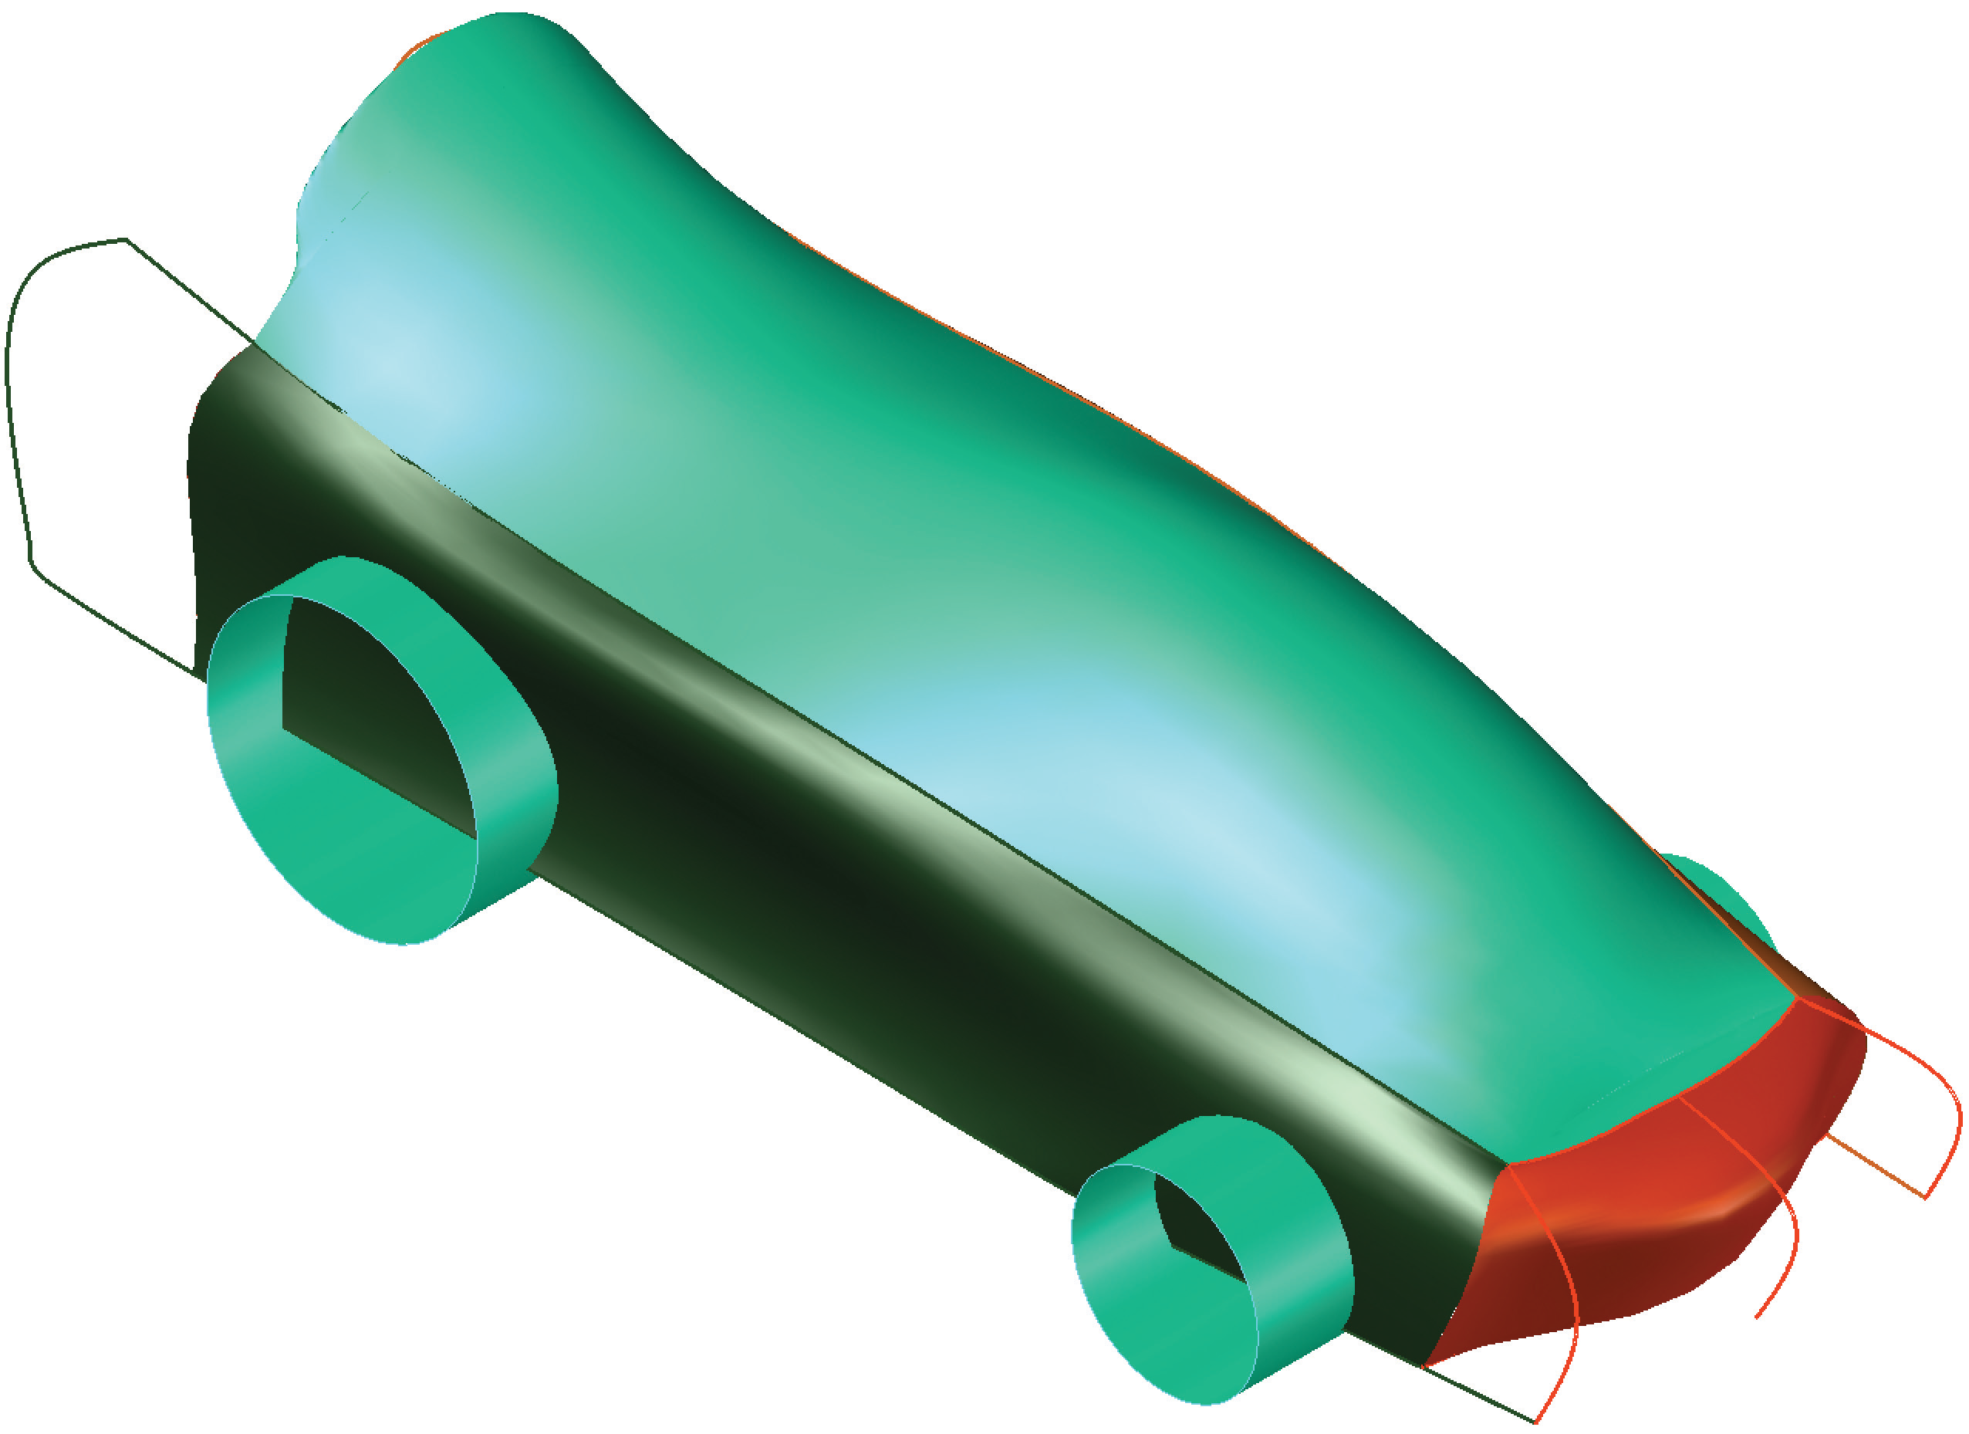
40. Pick the Trim button in the Edit panel on the Surface tab of the ribbon to initiate the SURFTRIM command.

41. Select both the left and right sides as the surfaces to trim. Select the two extruded circles (surface extrusions) as the cutting edges. Select the areas within the extruded circles as the areas to remove.

42. Set the Top layer current and freeze the Wheels layer.

43. Create a new layer named Construct, move any construction geometry curves to that layer, and freeze the layer. See the illustration below.

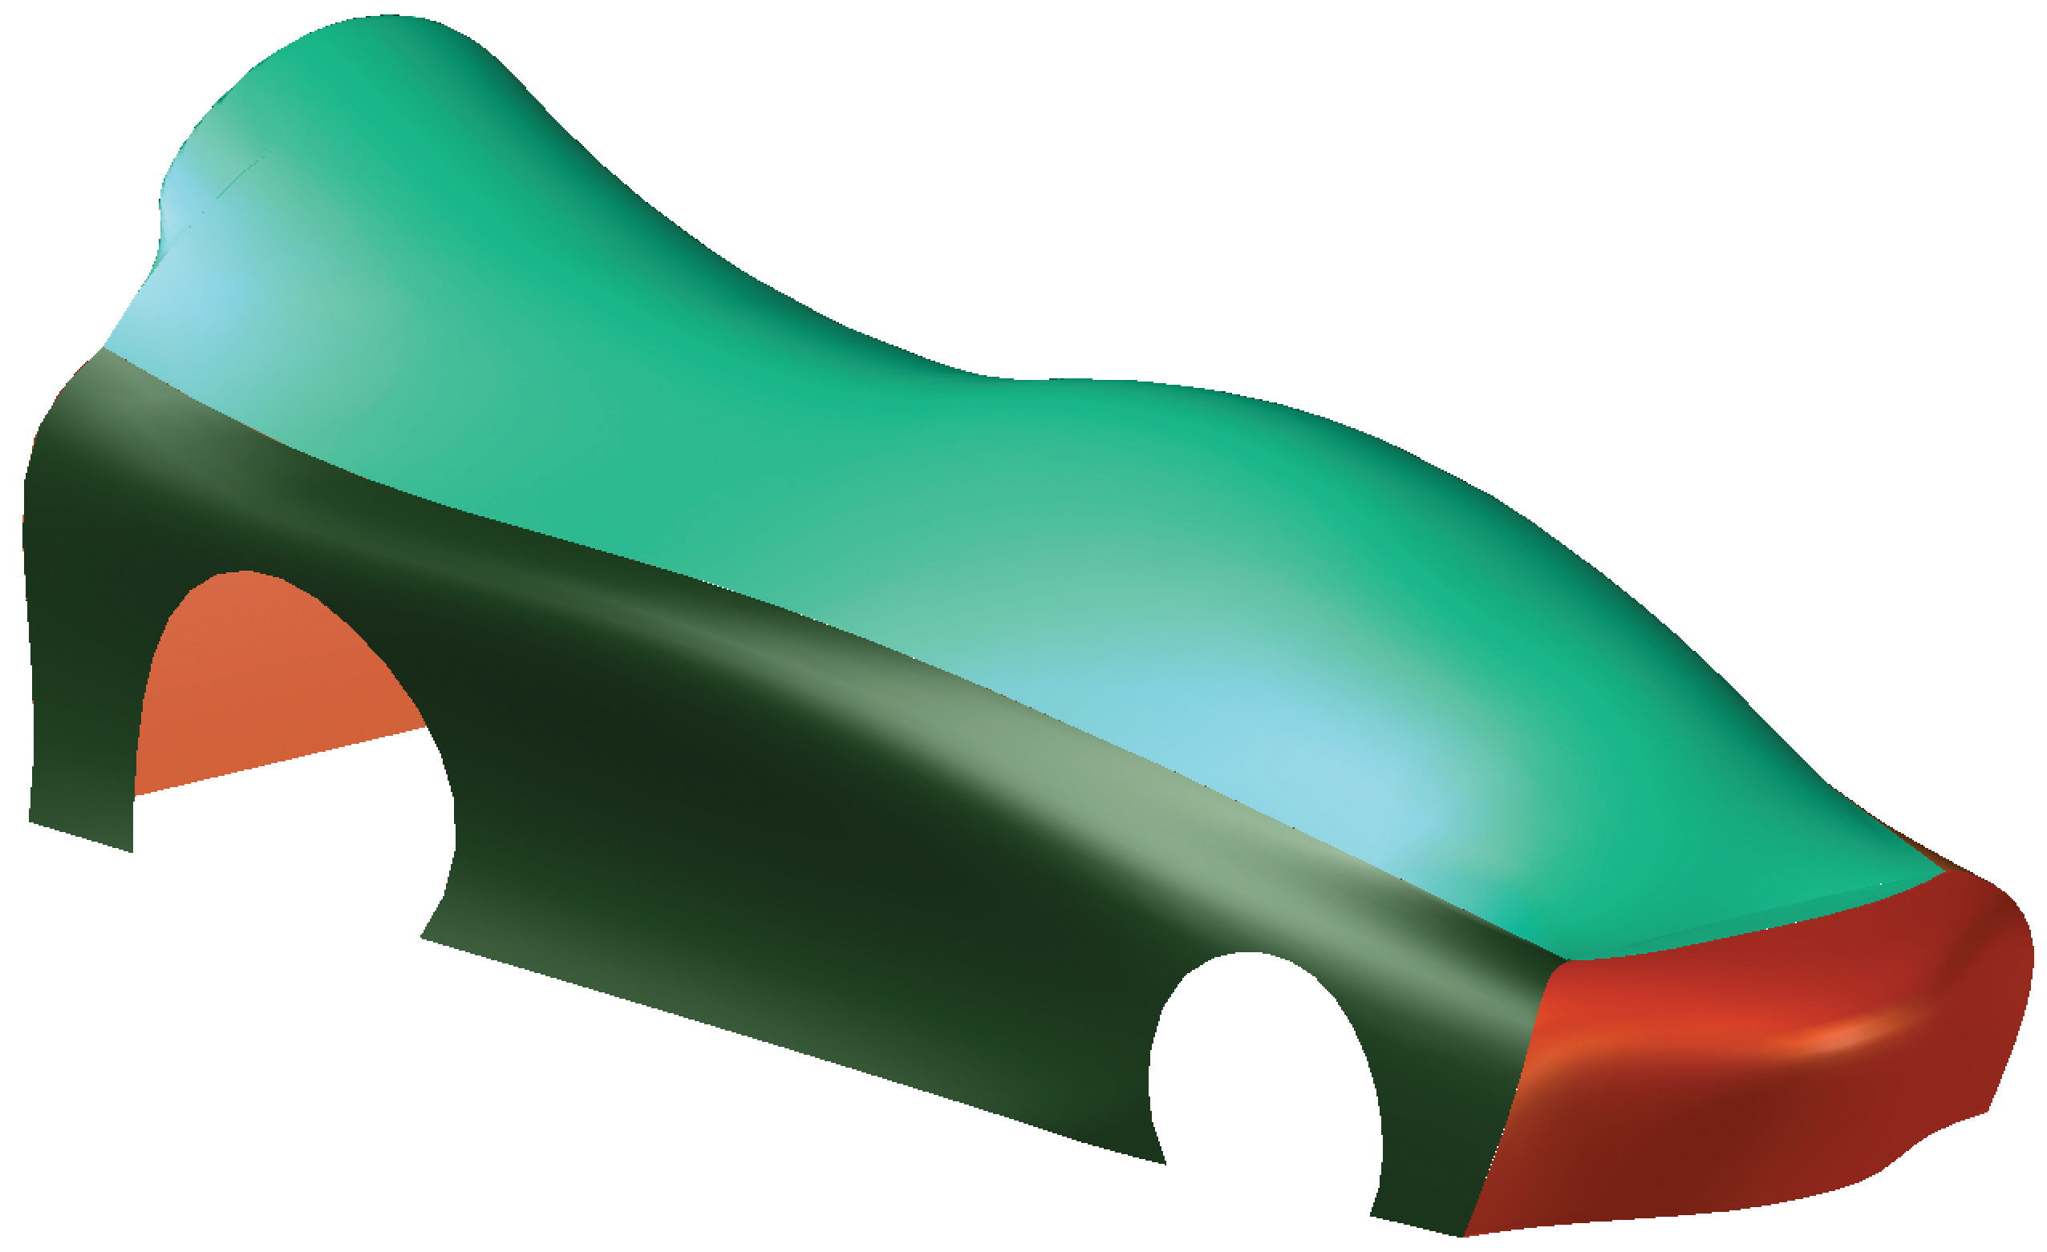

44. Save the drawing as Toy_Car_Body.dwg in your space.

