How to Make Your Own Titleblock Template

1) Open your AutoCAD program.
Set your units by clicking on the 'A' icon in the top left corner, select Drawing Utilities, select Units.

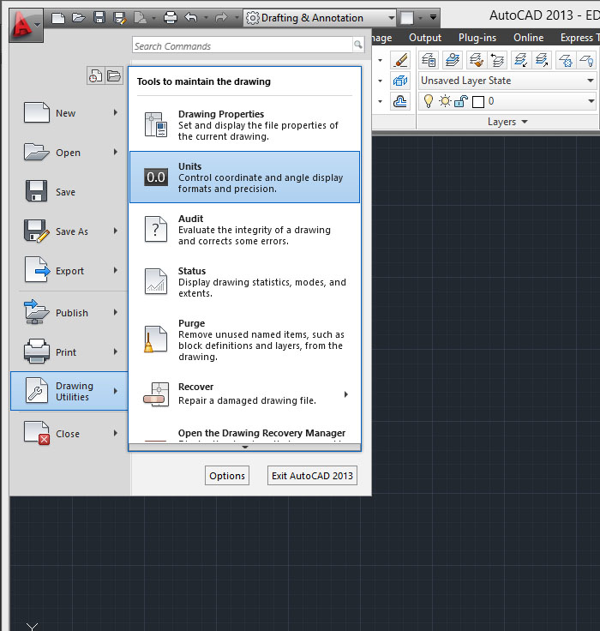

In the pop up window select the units, and precision you want.
I would recommend staying with the Decimal for now.

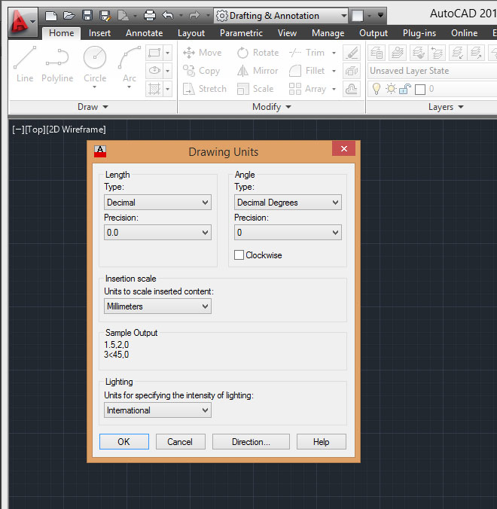

2) Select the Layer Properties box.

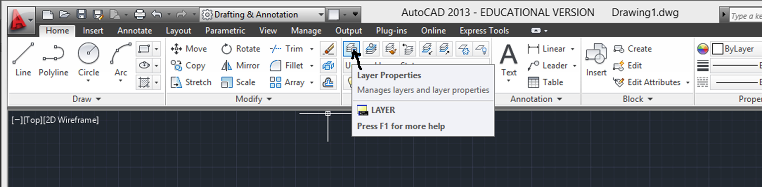
In the Layer Properties panel, select the New Layer Icon.

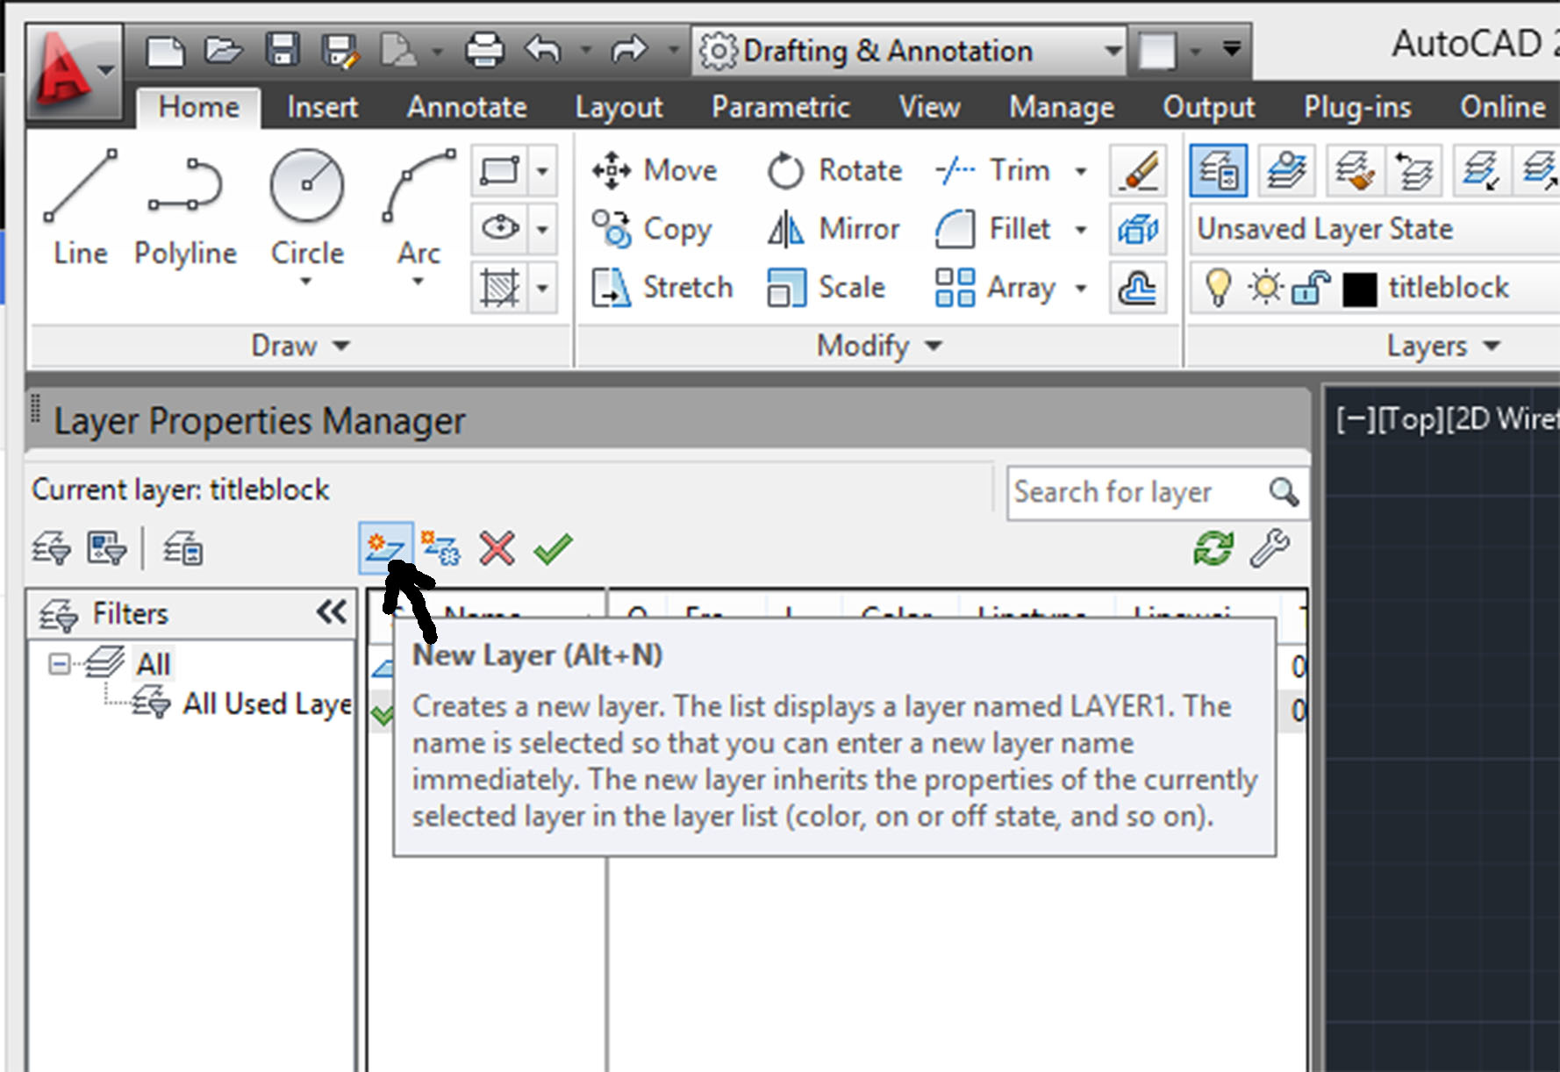
Click on the words Layer 1 and change the name to Titleblock.

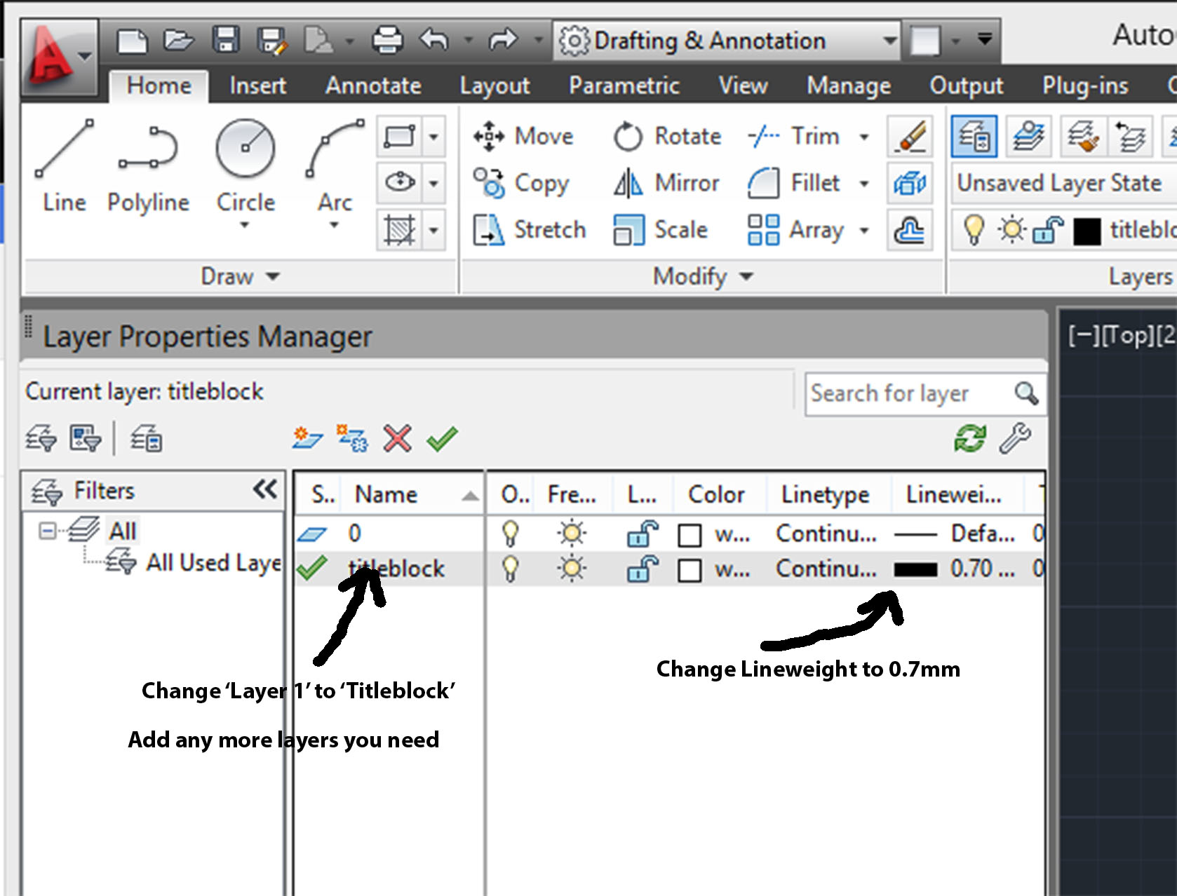
Click the line under the Lineweight heading and set your line thickness to 0.7mm in the pop up window.
Now is a good time to add any other layers you would normally use such as object, text, walls, windows, or doors layers. NOTE: Dimensions are done in Model space not here.

3) In Model space and on the Titleblock layer, draw a rectangle to match your page size (see below). Make sure your drawing units match with your setup units.

Common paper sizes Imperial (In) Metric (mm)

Letter (Landscape) 11 x8 1/2 279 x 216
Large Format 36 x 24 914 x 610

4) Try to use the OFFSET tool to create a border 10 to 15 mm inside your page edges in order to set an equal distance in from each edge.

5) Continue to draw your title block inside your border as you wish.

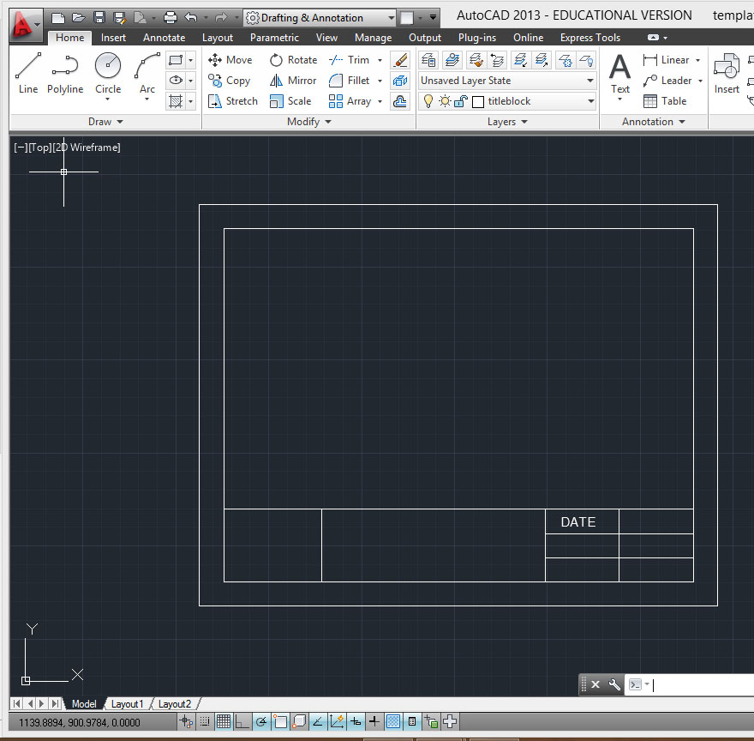
6) You should add appropriate text boxes with temporary text which you can change later.
Select Multiline Text (the big 'A' in the tool ribbon).
Draw the text box so that it matches the size of the titleblock box.
Set your text size to 5mm.

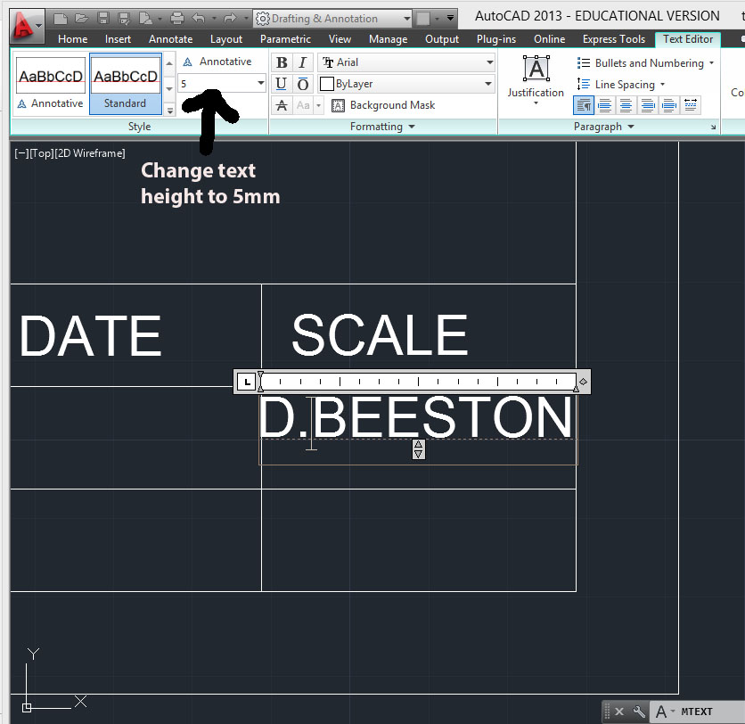
Put in default text for now and you can change them when you start your future drawings.
Center the text box in the titleblock box and reduce it length so it doesn't overlap the next box.

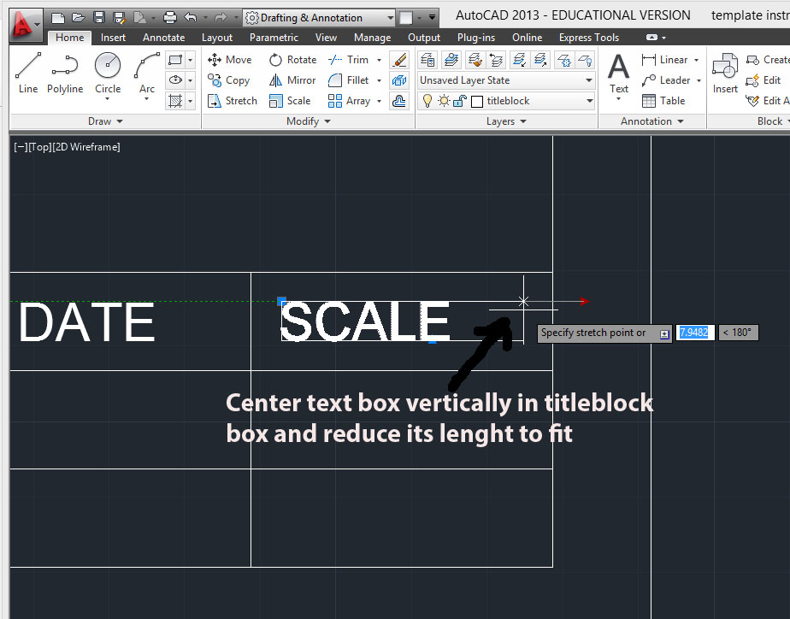

7) Once you are happy with your border and title block, select Save As, select Templete, and name the file Titleblocks. Make sure to save into your space!

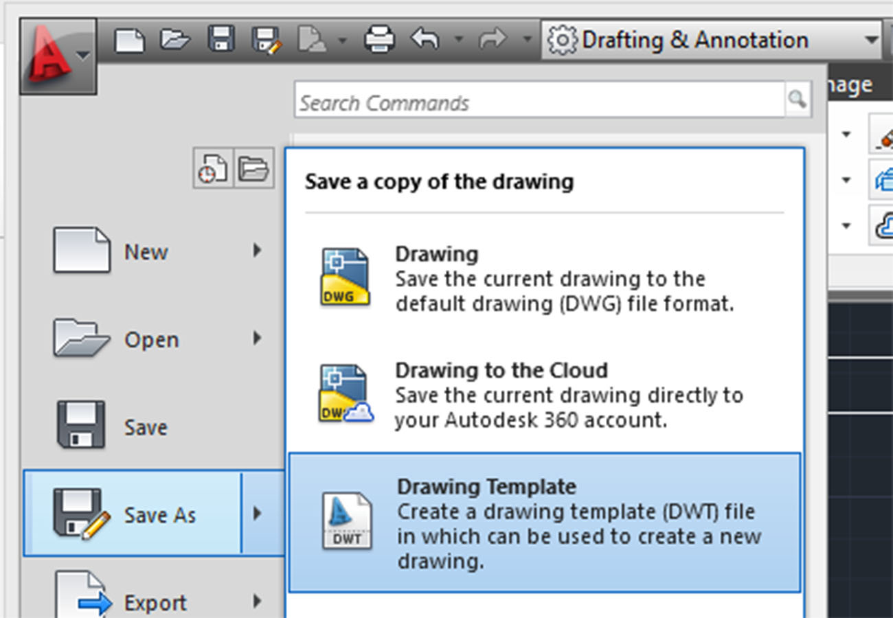

Select your entire drawing right click, select Clipboard, select Copy with Base Point.
Select the bottom left corner of your drawing.

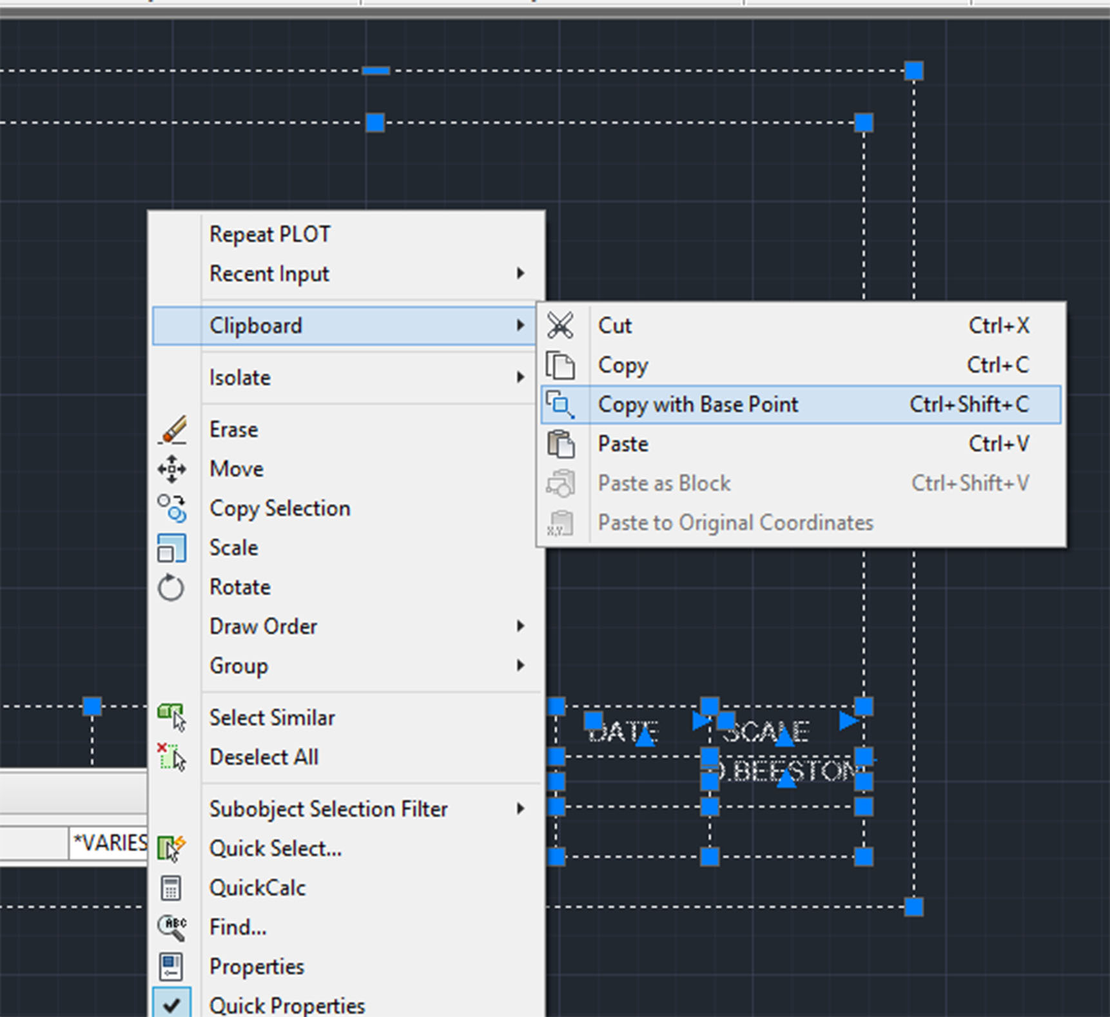

8) Select your first 'paper space' tab which is usually called Layout 1 and is located in the bottom left of your screen.

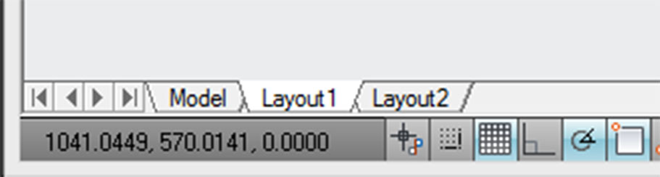

9) You should see your titleblock drawing in a viewport.
Select and delete this viewport.

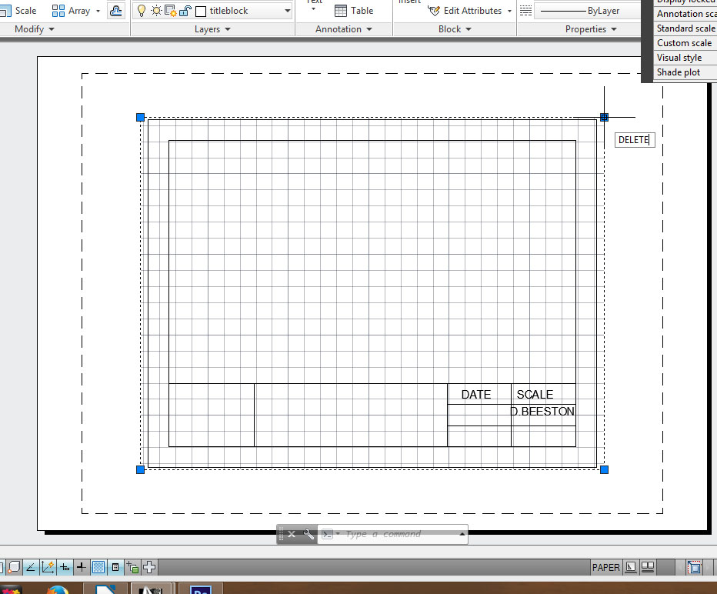

10) Click the 'A' icon in the top left corner of your screen, select Print, select Plot.

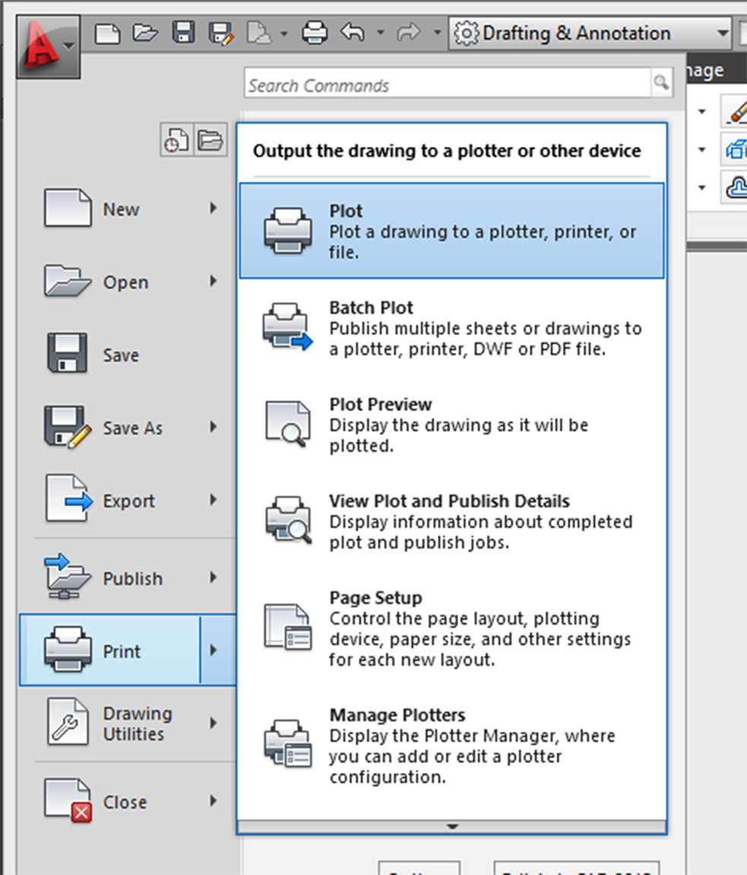
A pop up window titled 'Plot – Layout 1' should appear in the middle of our screen.
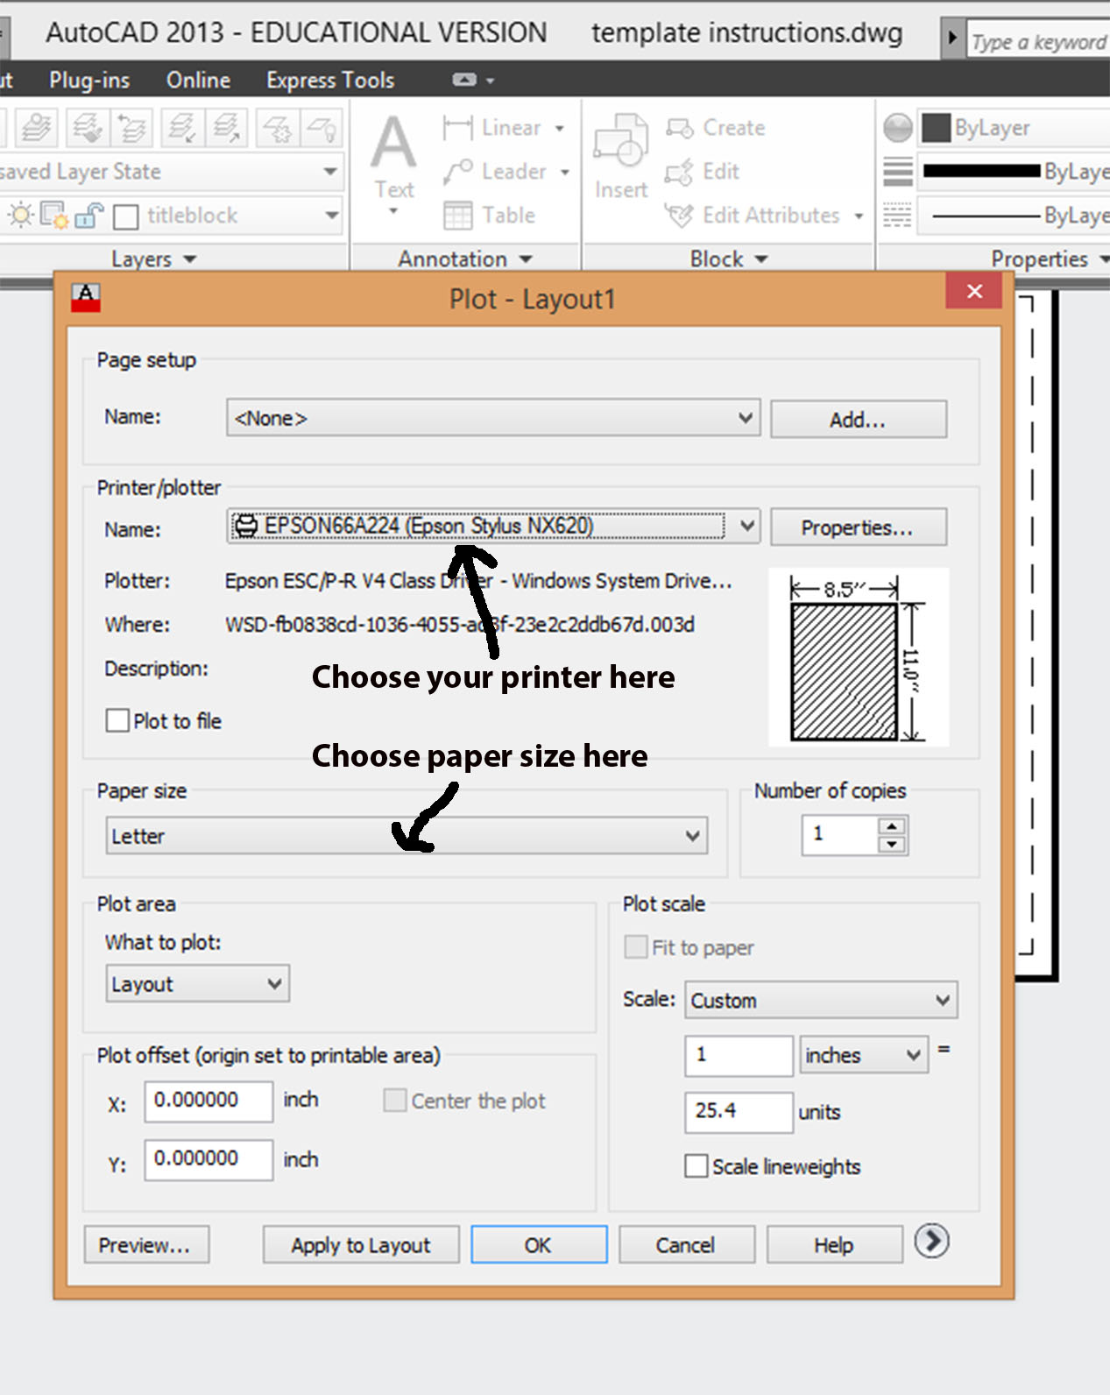
Select the correct print, paper size, and orientation you want.

11) Right click, select Clipboard, select Paste and click your cursor on the bottom left corner of the paper on the screen.
You should see your titleblock appear in the correct position on the page.

12) Type 'viewport'.
Select Single and OK

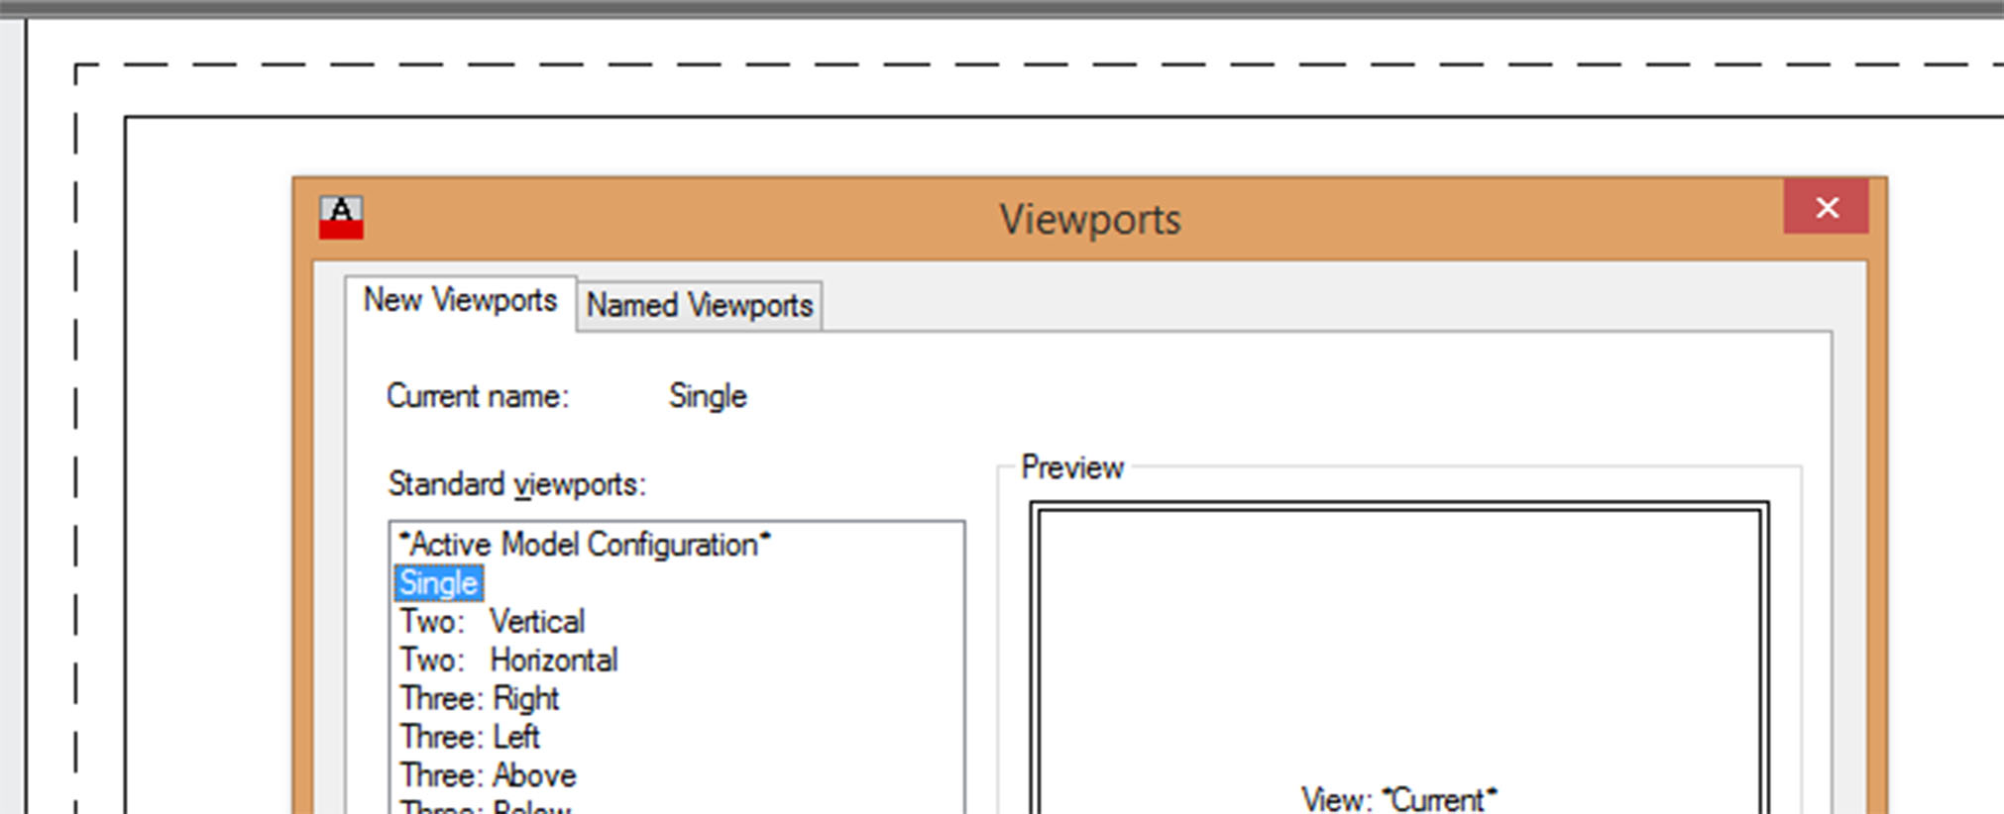
Click the top left of the border and drag down to the right and click on the top right of the titleblock.
You should see your drawing in a perfectly positioned viewport.
You can change to number of viewports on future drawings.

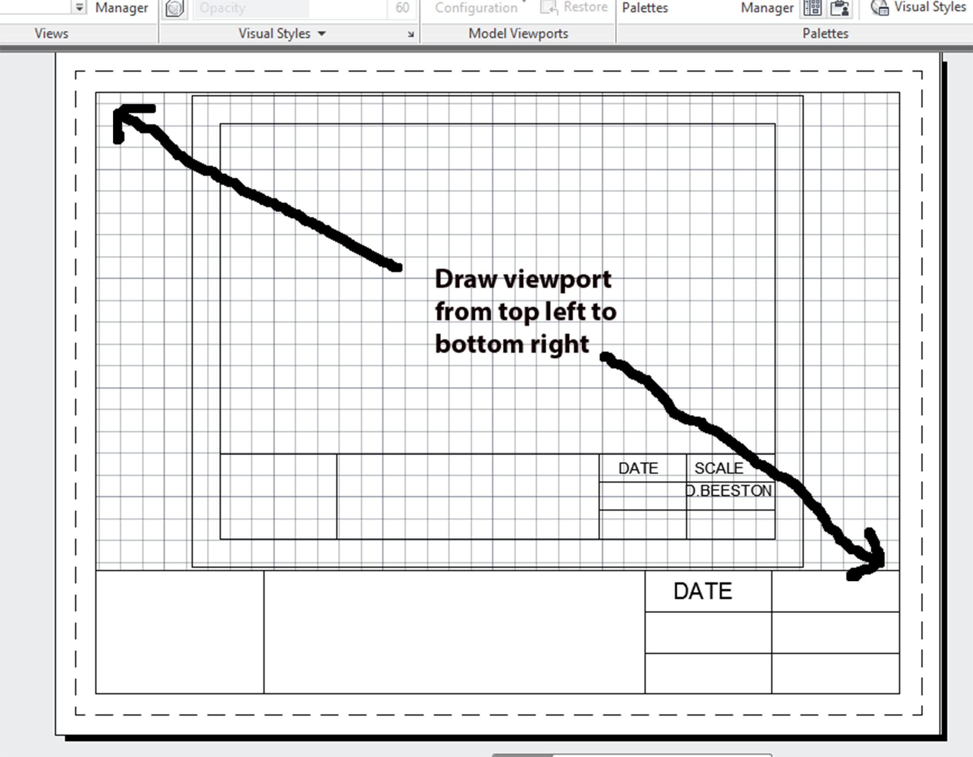
13) Click on the Model tab to return to model space and select and delete your entire drawing.
You now have a blank model space and a Letter titleblock. SAVE AGAIN!!!

14) Repeat the procedure (starting at step 3) for a Large format titleblock.
Use the 2nd Layout tab (Layout 2)for this titleblock.
You can change the titles of the tabs by double clicking on them.
Name them something obvious like Letter and Large Format respectively.
You can add new layout tabs by right clicking on a tab and selecting New Layout.

You should now have 2 templates on a single template file.
You should open this document first before starting any future drawings in order to save yourself a lot of time.

