Getting images from Sketchup into your Document

1) In sketchup, orient the object to show the view you want. Try to fill the screen as much as possible without cutting any part off.

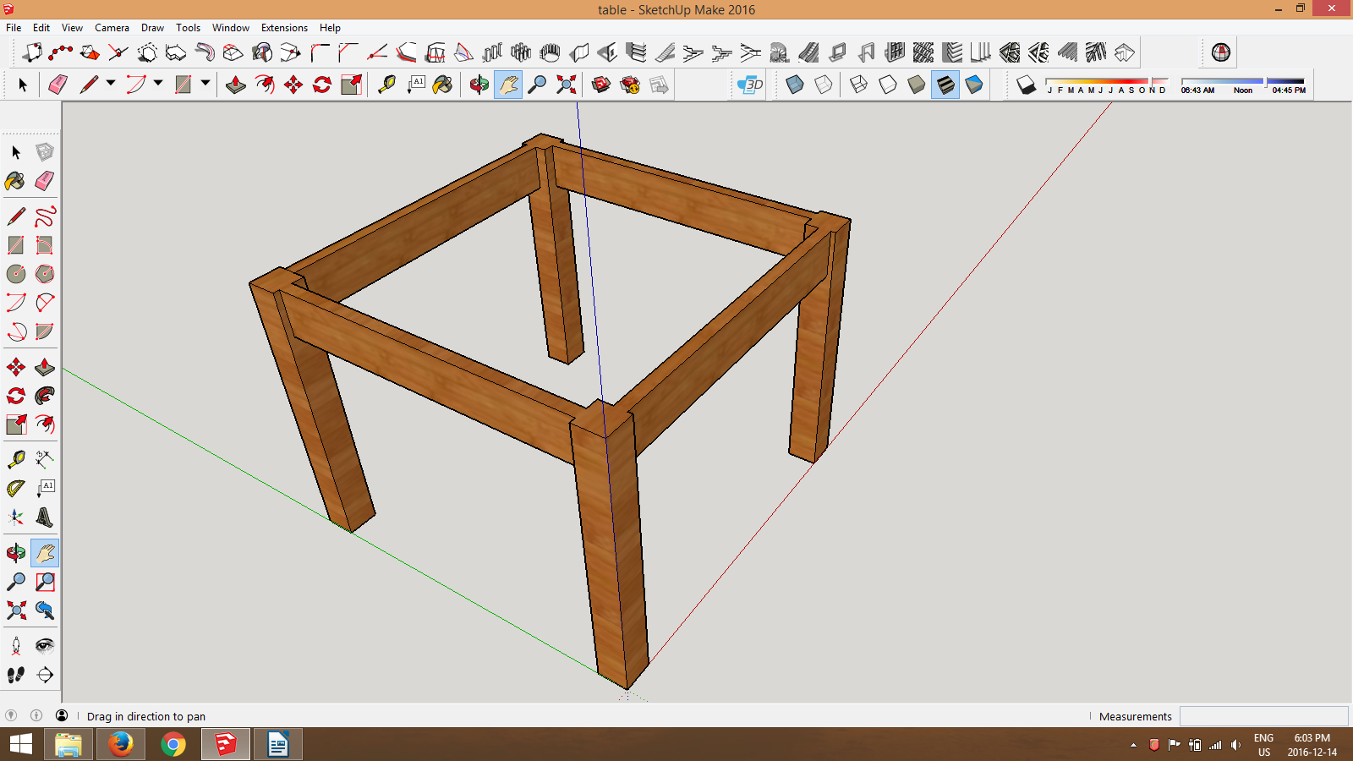

2) Under File, Select Export, Export 2D, 2D Graphic.

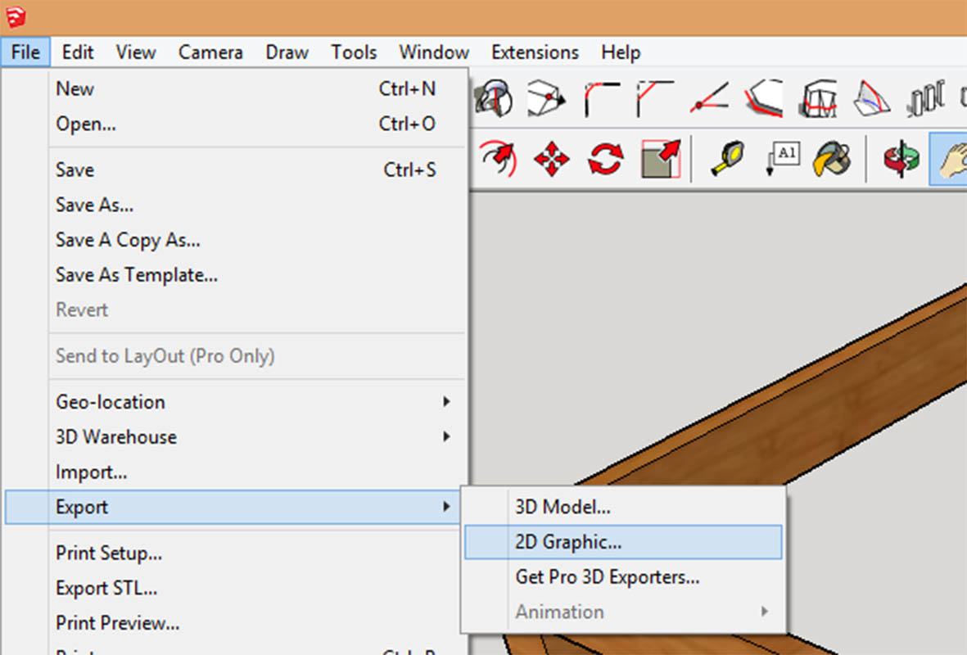

In the pop up window, change destination to 'Desktop', name your file, change to file type to '.jpg', click 'Export' button.



